varsha

B Sc. (Hons.) Computer

Science

Operating Systems

Practical File

2. Execute various Linux commands for:

i. Information Maintenance: wc, clear, cal, who, date, pwd

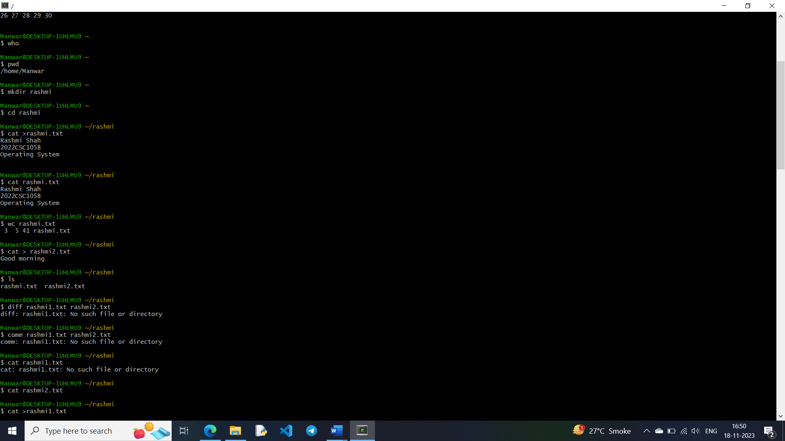

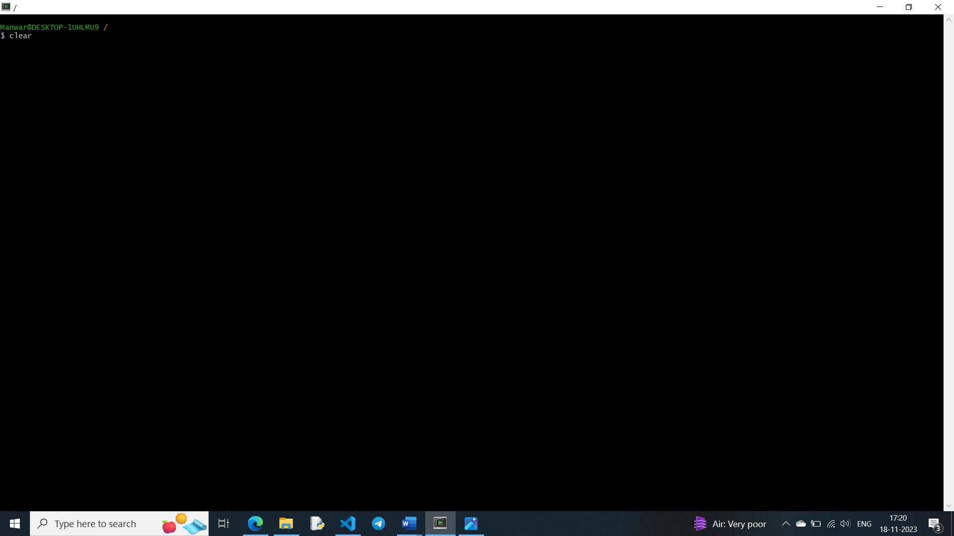

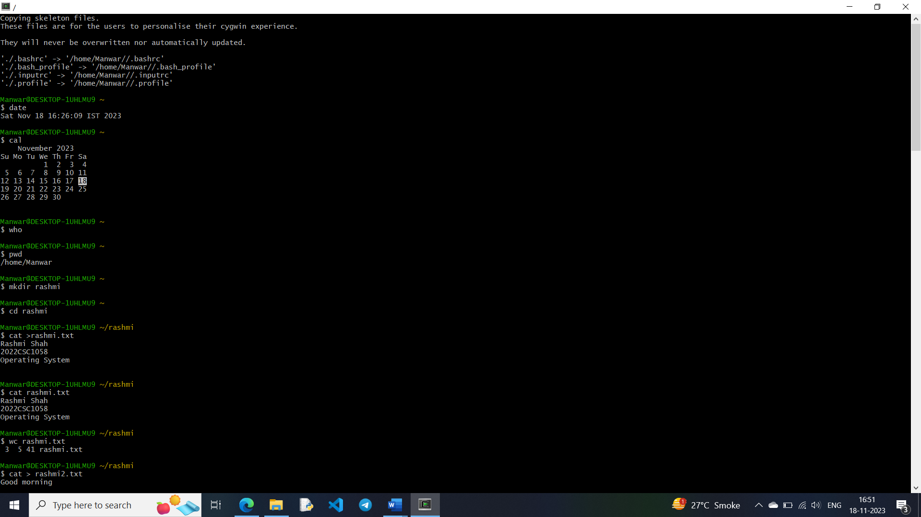







ii. File Management: cat, cp, rm, mv, cmp, comm, diff, find, grep, awk

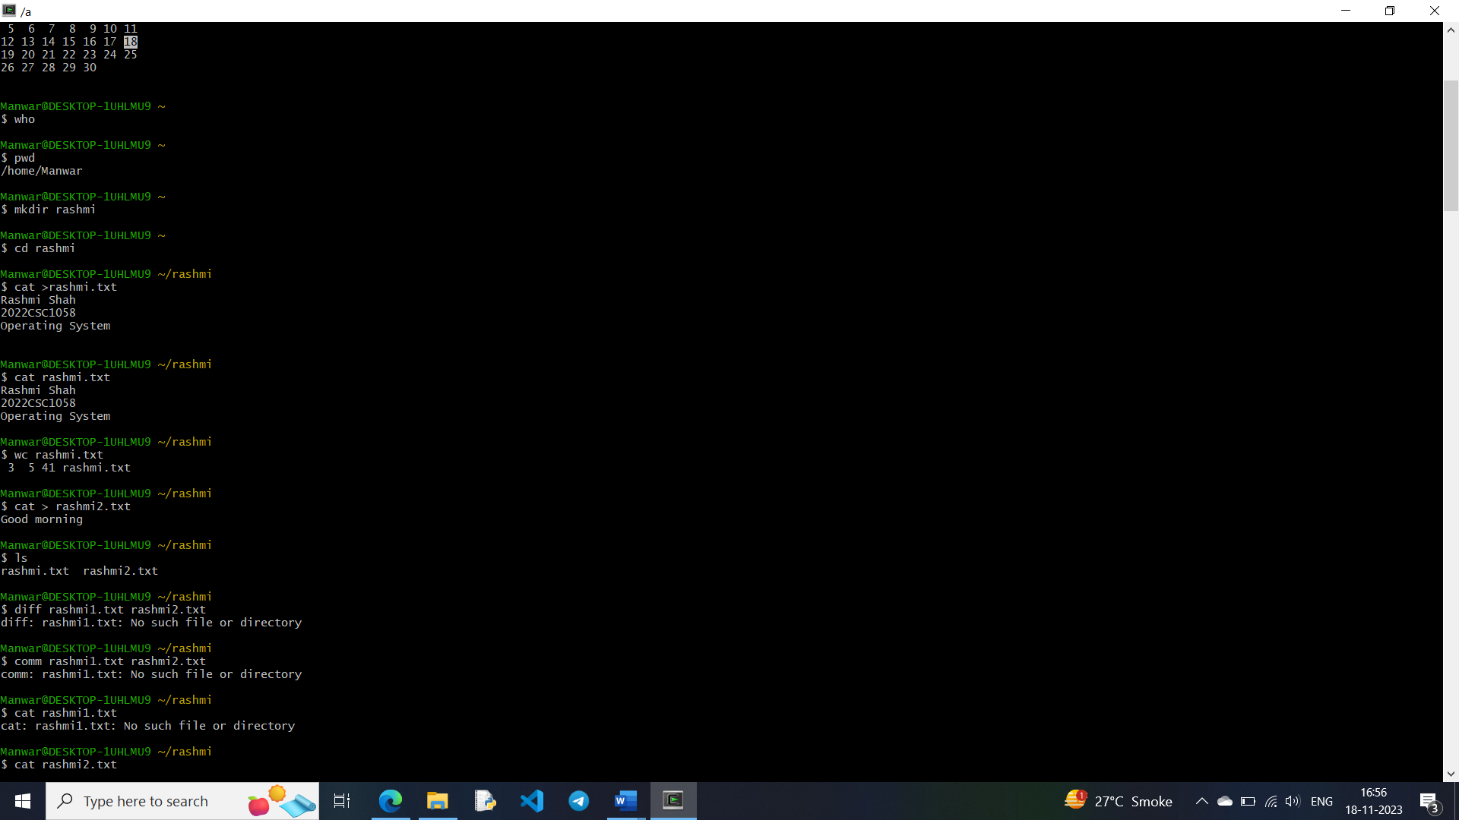

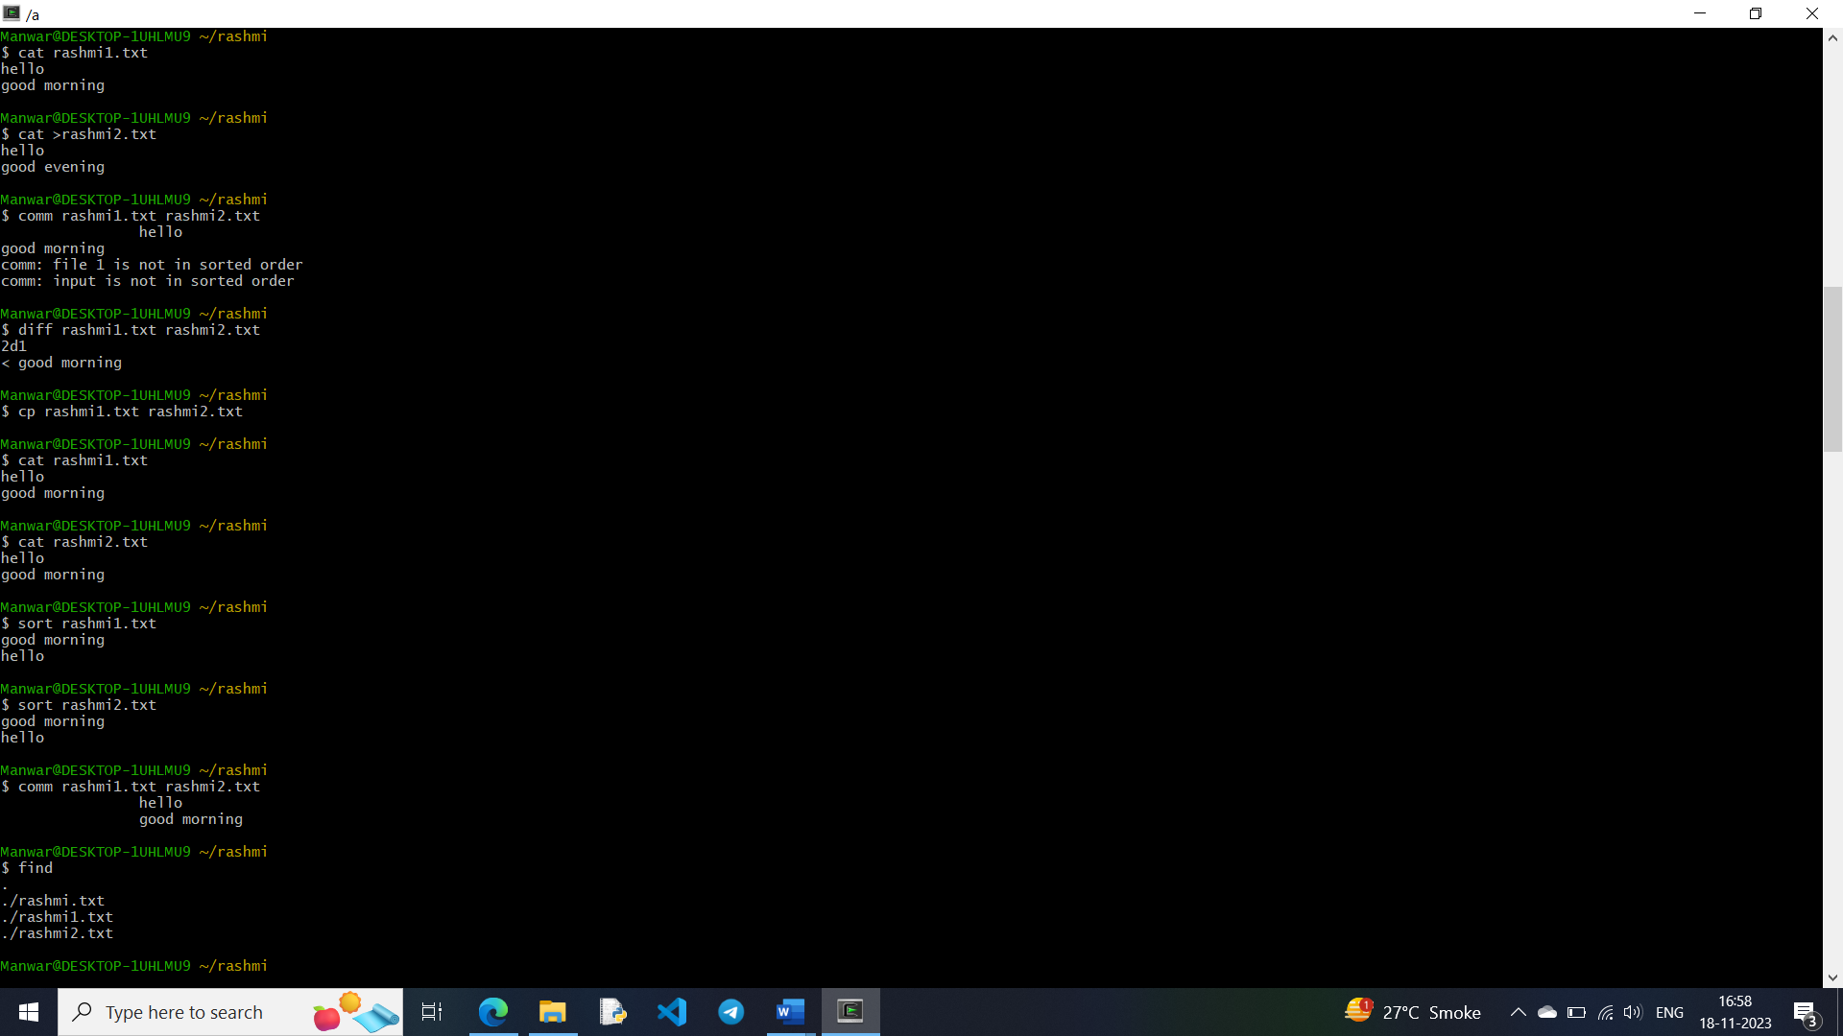

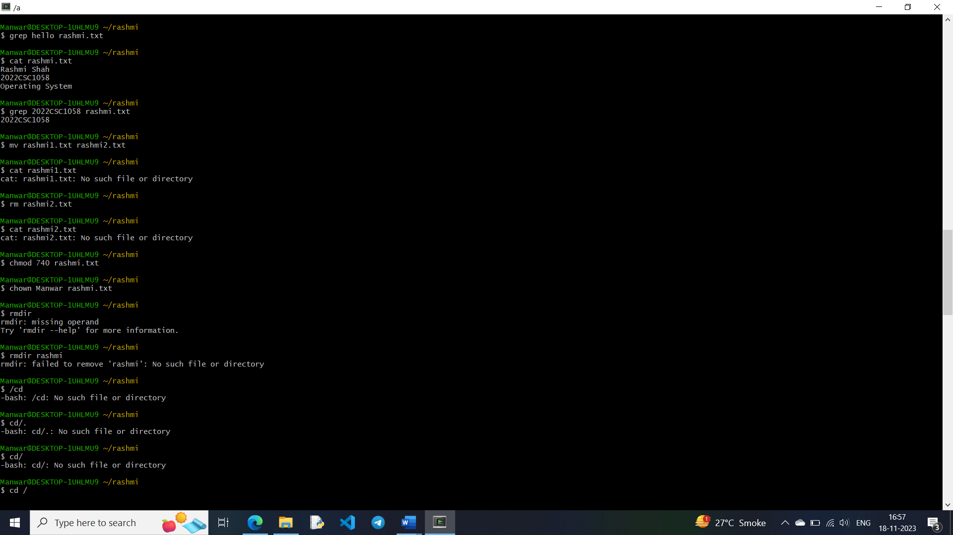



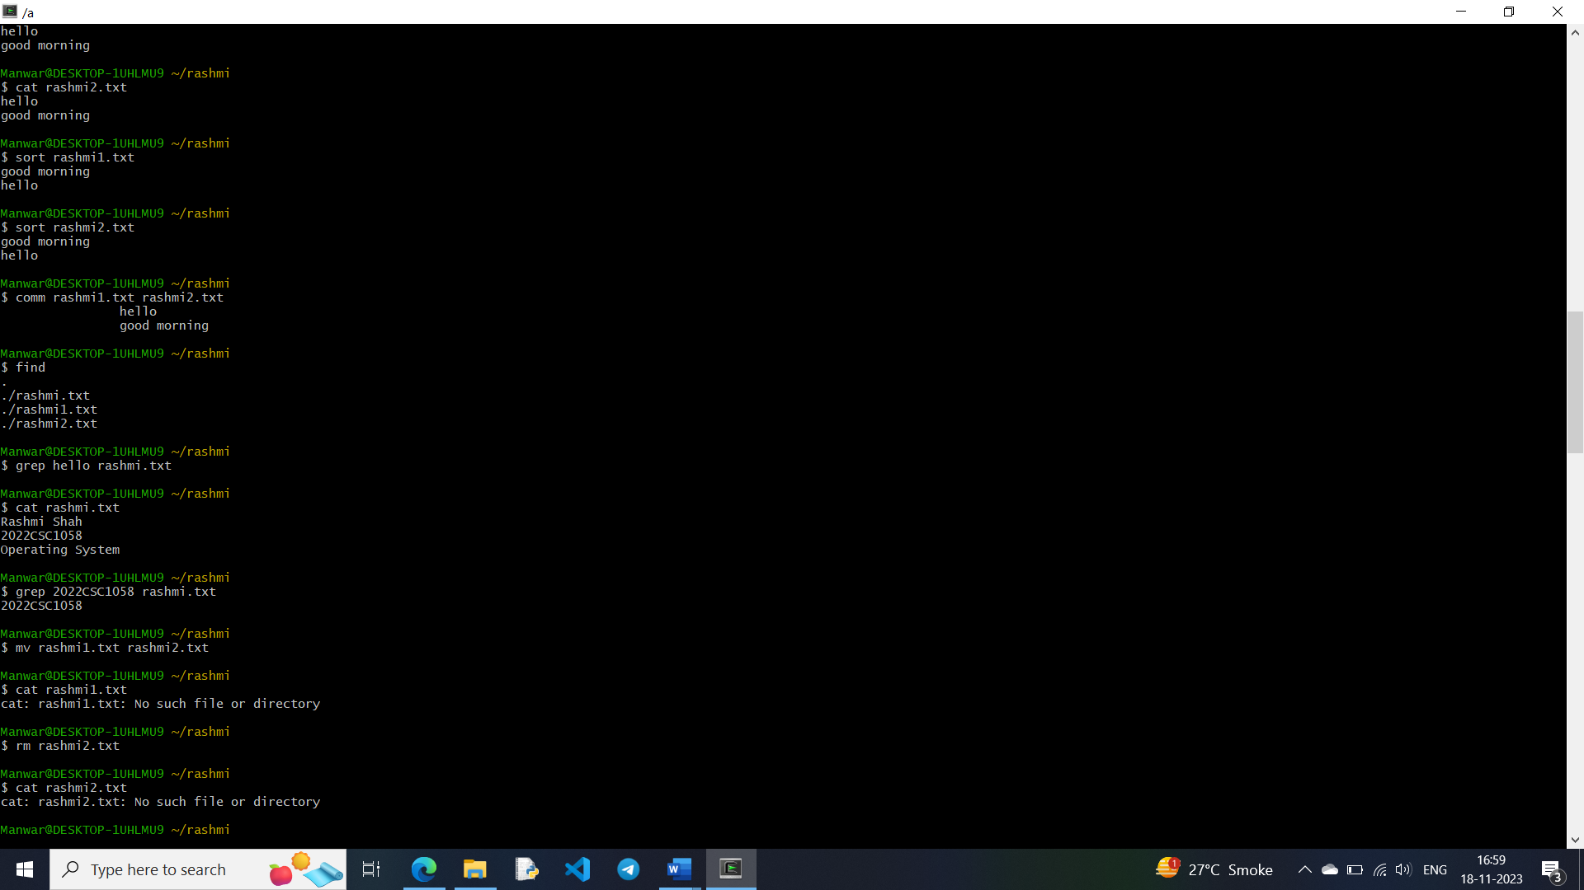

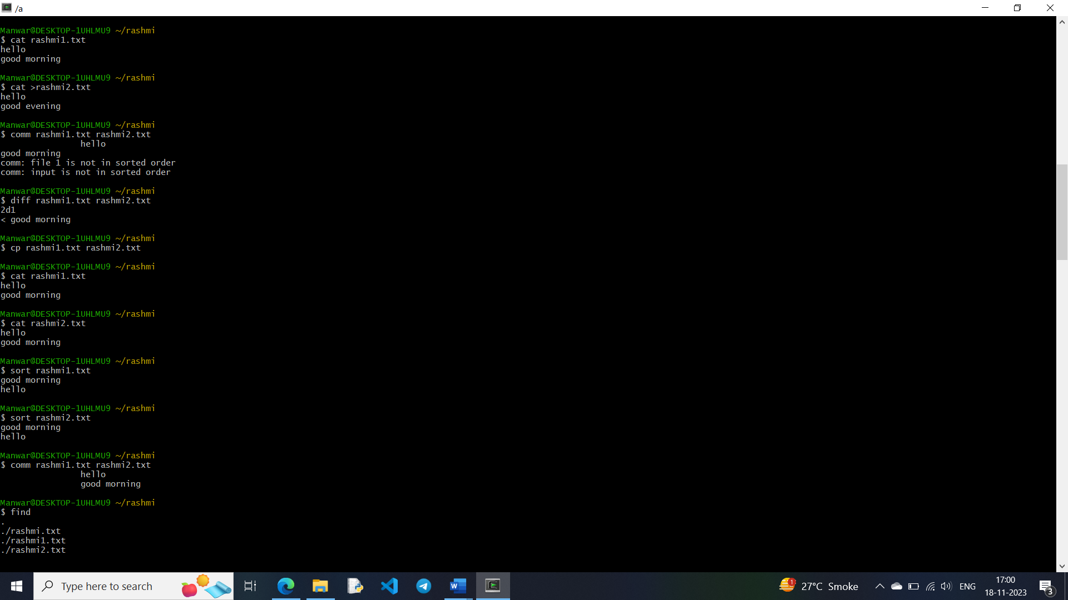

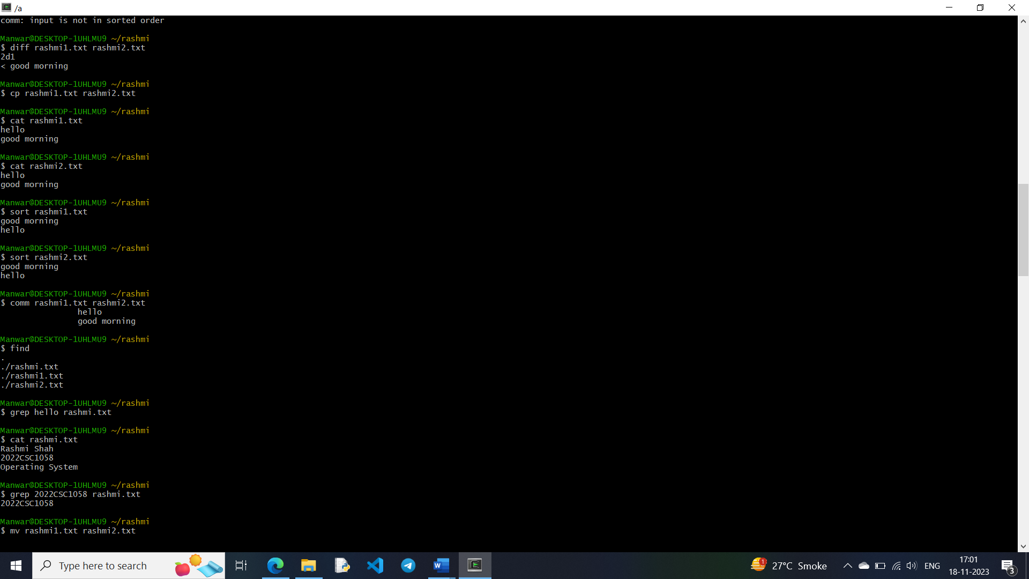

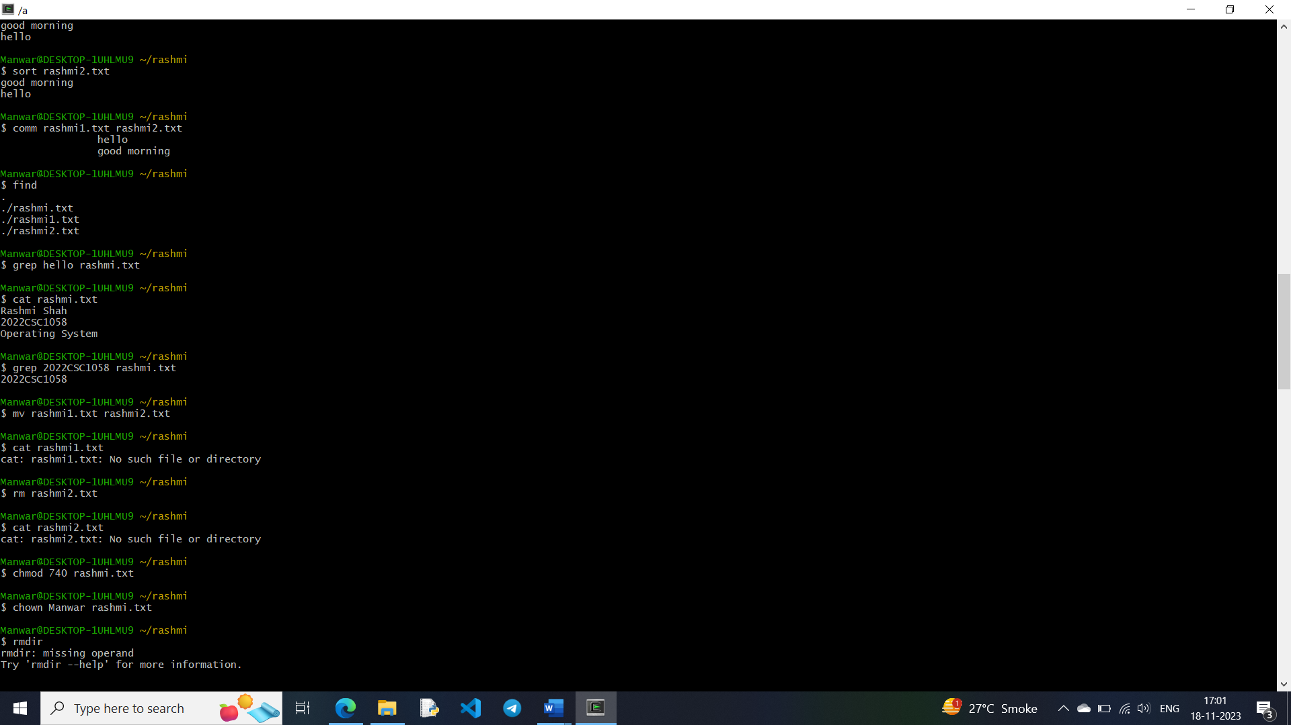

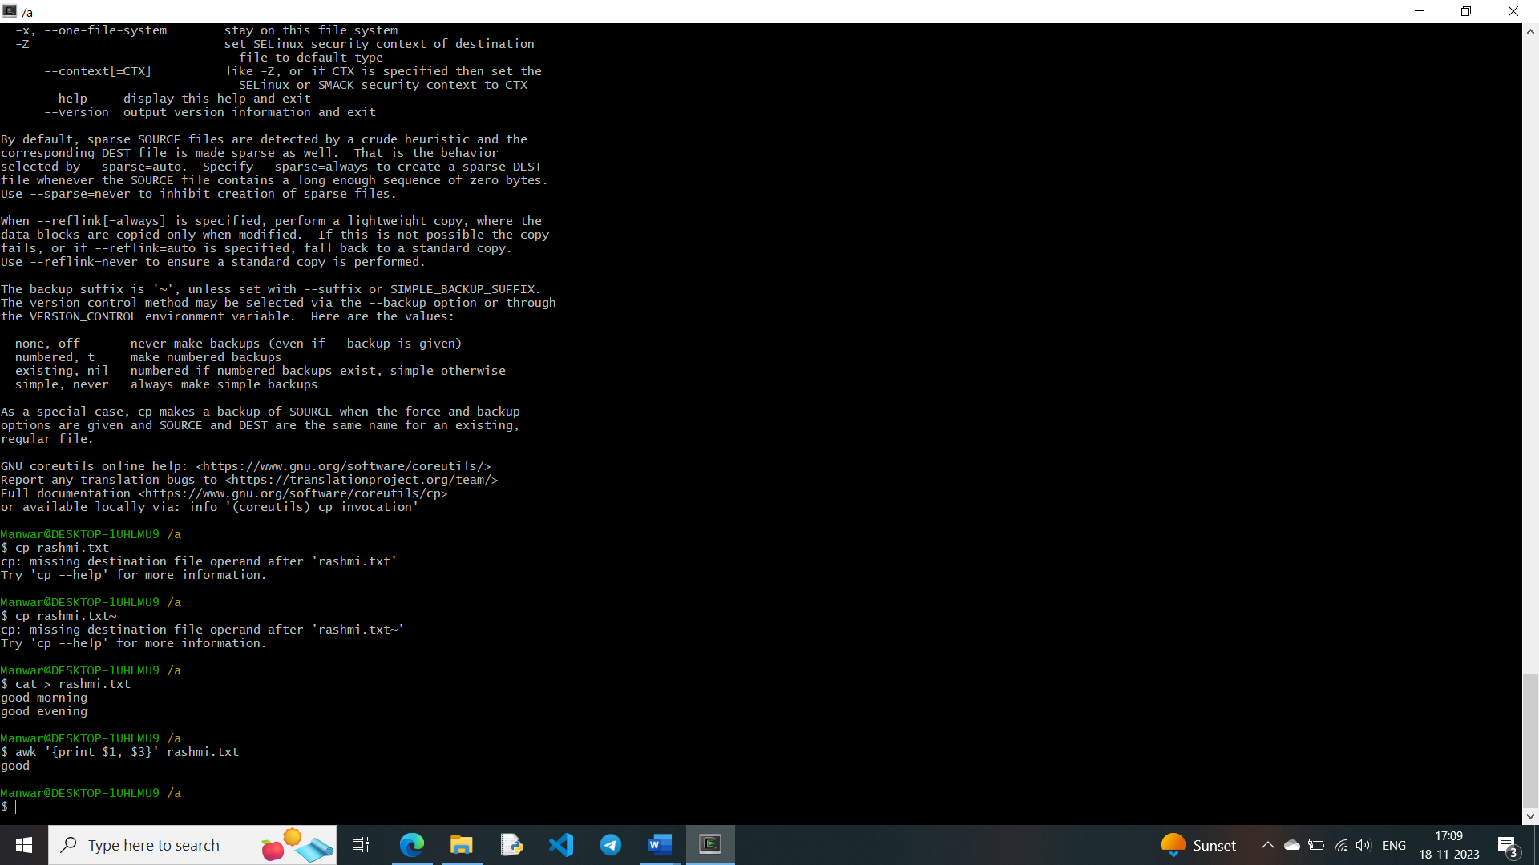

(iii) Directory Management : cd, mkdir, rmdir, ls

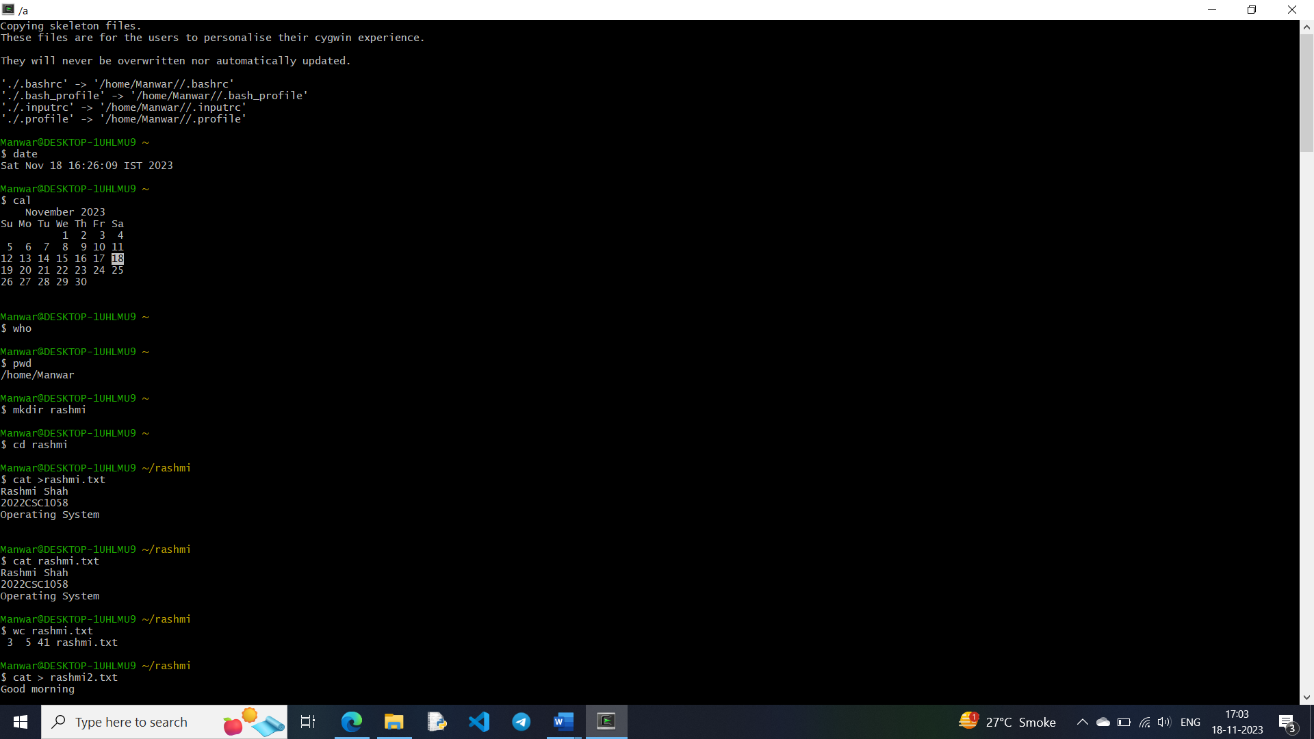



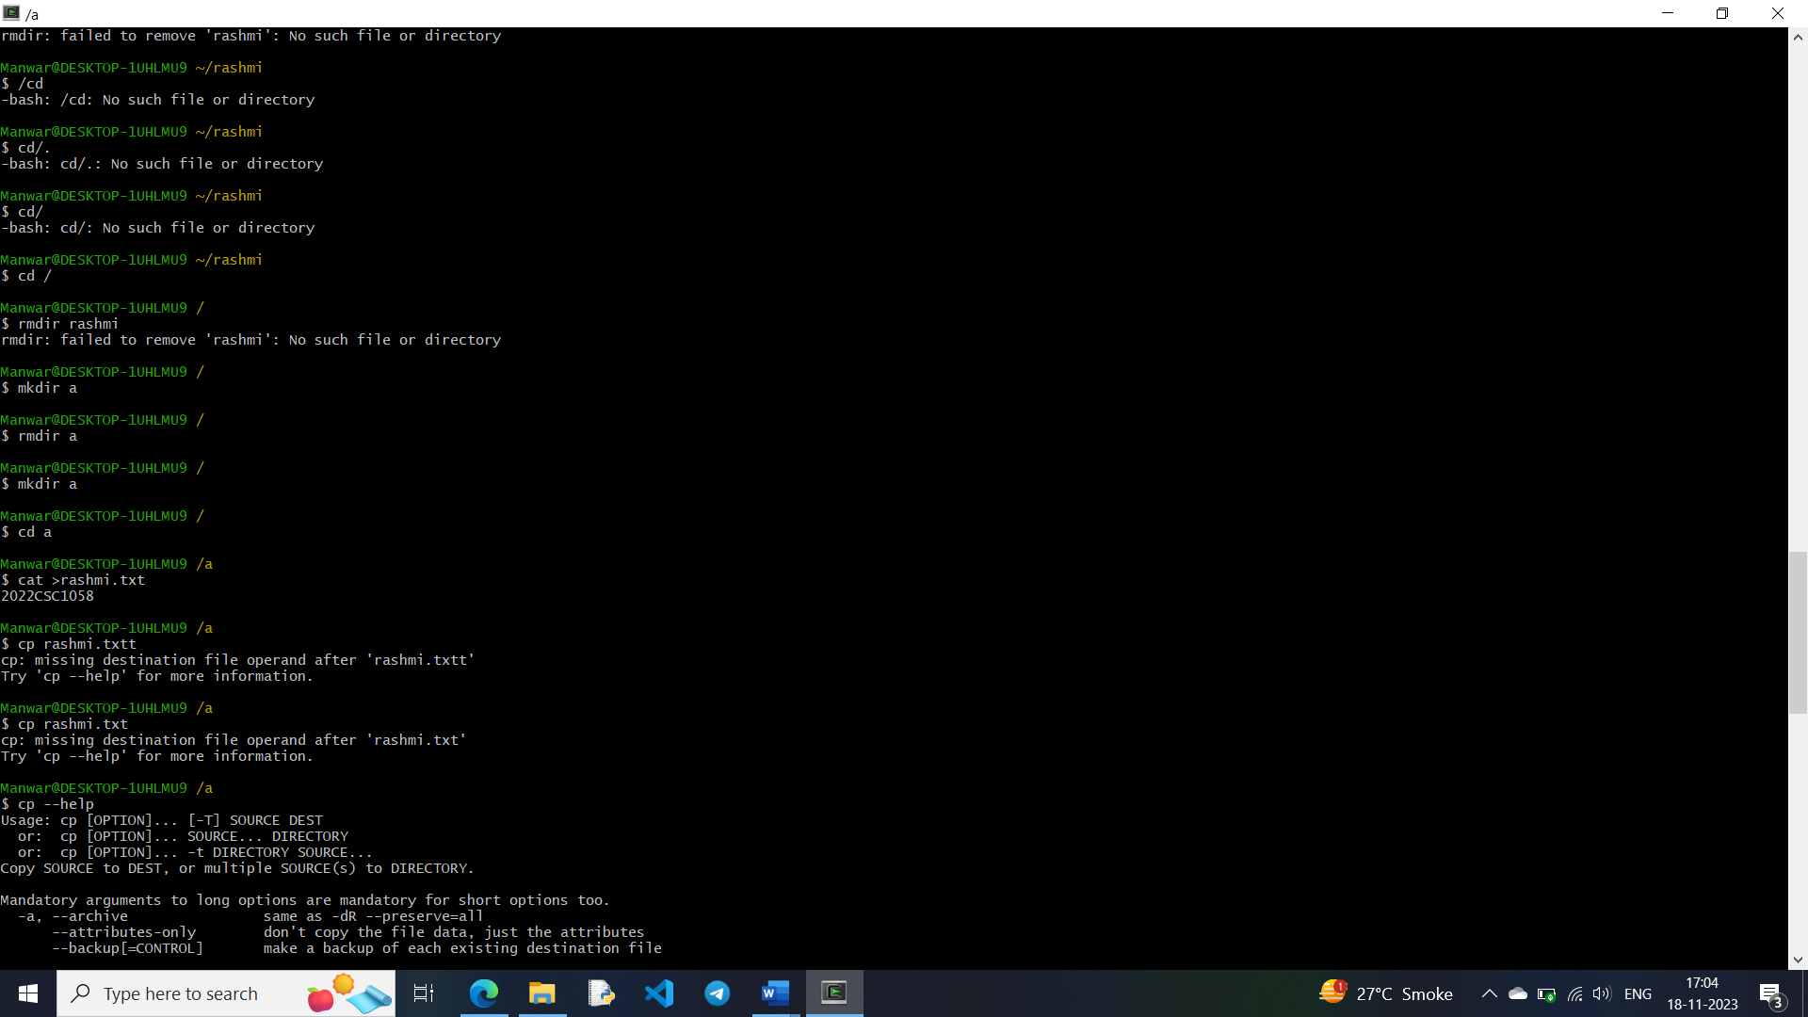

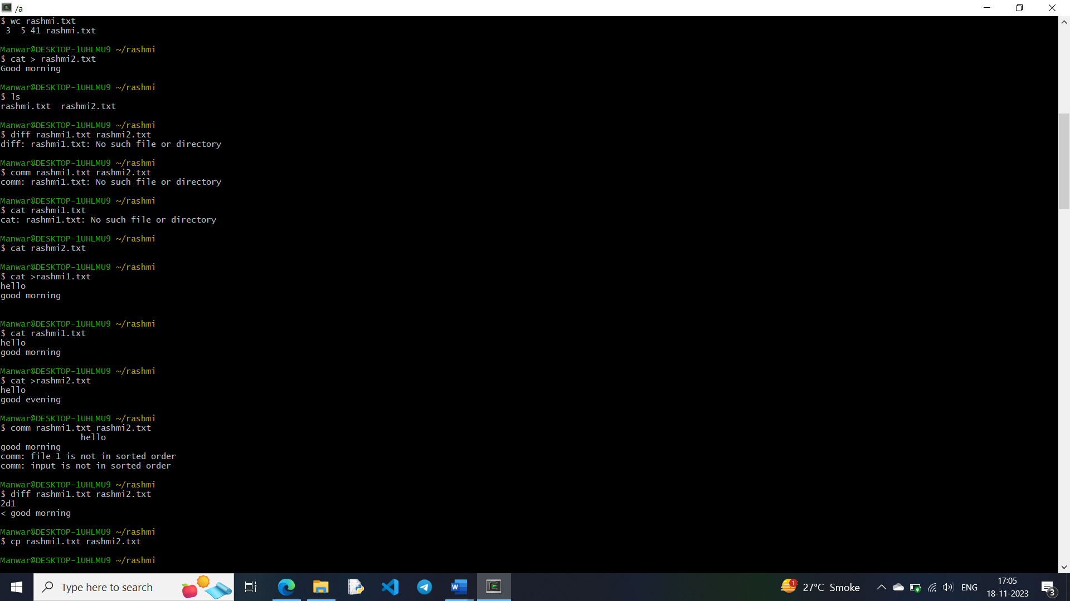

3. Execute various Linux commands for:

i. Process Control: fork, getpid, ps, kill, sleep

#include <unistd.h>

#include <iostream>

using namespace std;

int main() {

pid_t pid;

pid = fork();

if (pid == -1) {

cout << "Error" << endl;

}

else if (pid == 0) {

cout << "Child process" << endl;

cout << getpid() << endl;

cout << getppid() << endl;

}

else {

cout << "Parent process" << endl;

cout << getpid() << endl;

}

return 0;

}

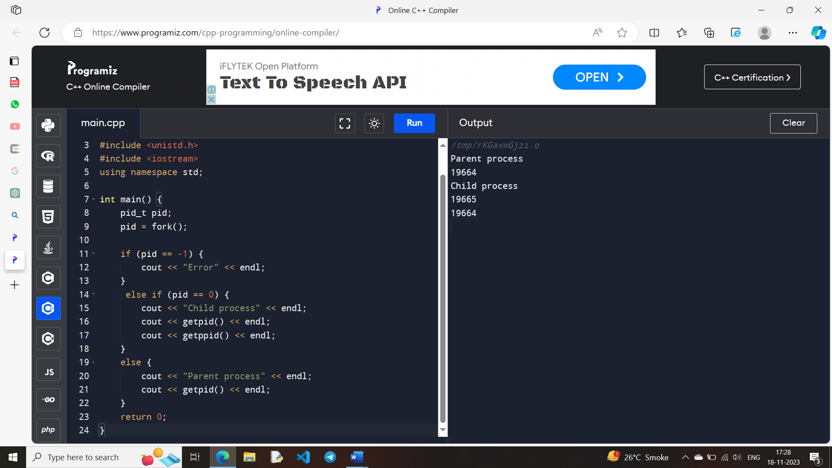

#include <unistd.h>

#include <iostream>

using namespace std;

int main() {

pid_t pid;

pid = fork();

if (pid == -1) {

cout << "Error" << endl;

}

else if (pid == 0) {

cout << "Child process" << endl;

sleep(1);

cout << getpid() << endl;

cout << getppid() << endl;

}

else {

cout << "Parent process" << endl;

cout << getpid() << endl;

}

return 0;

}

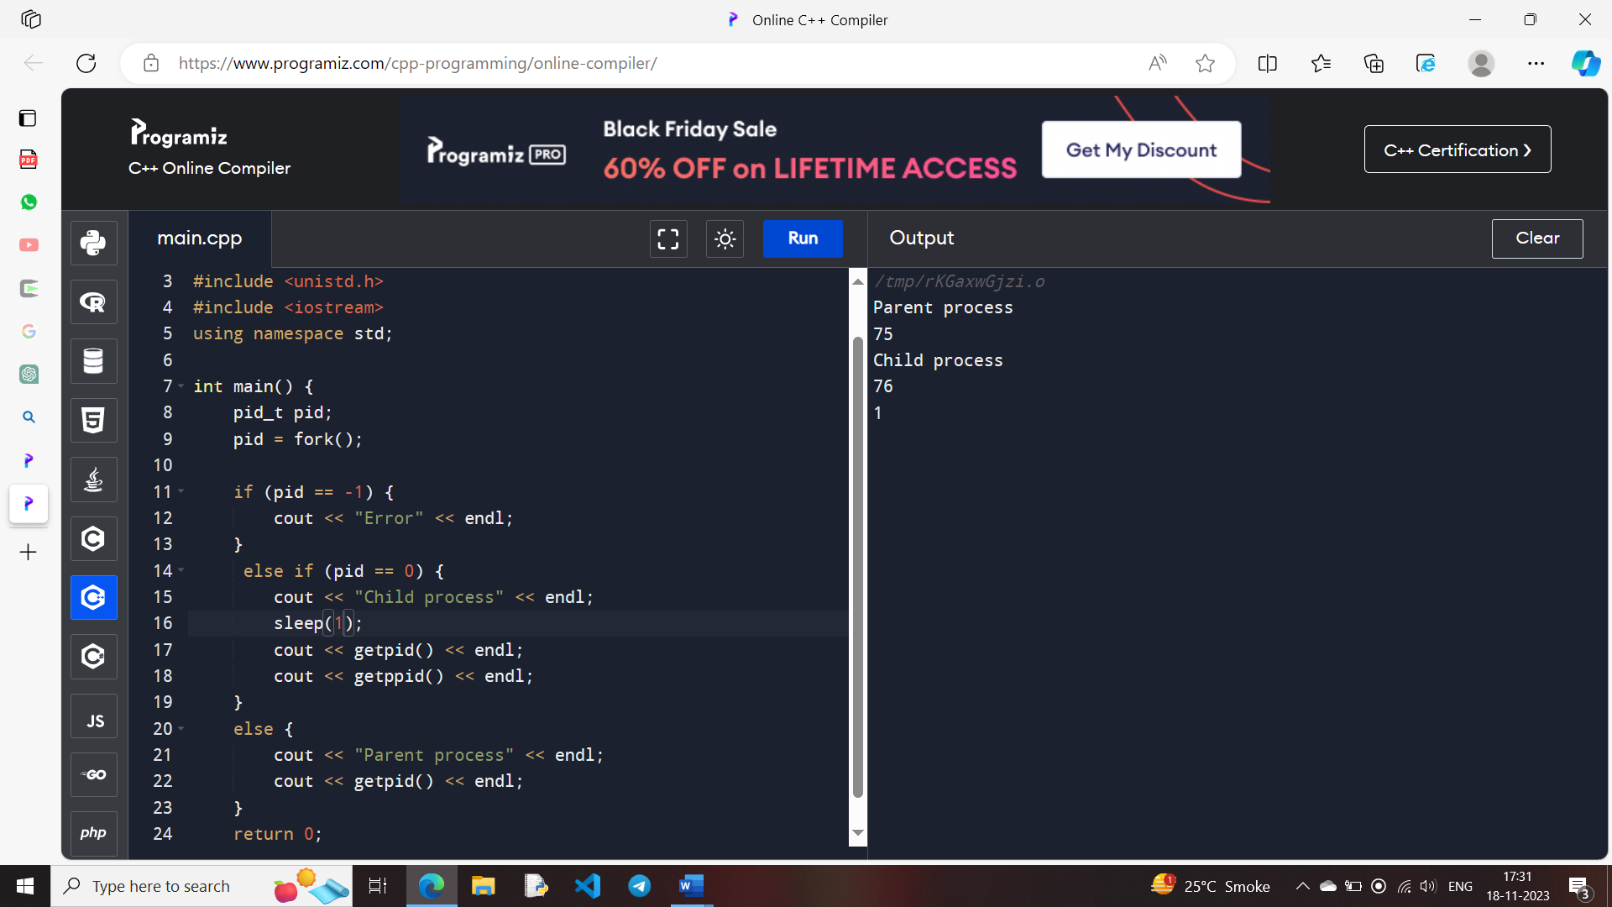

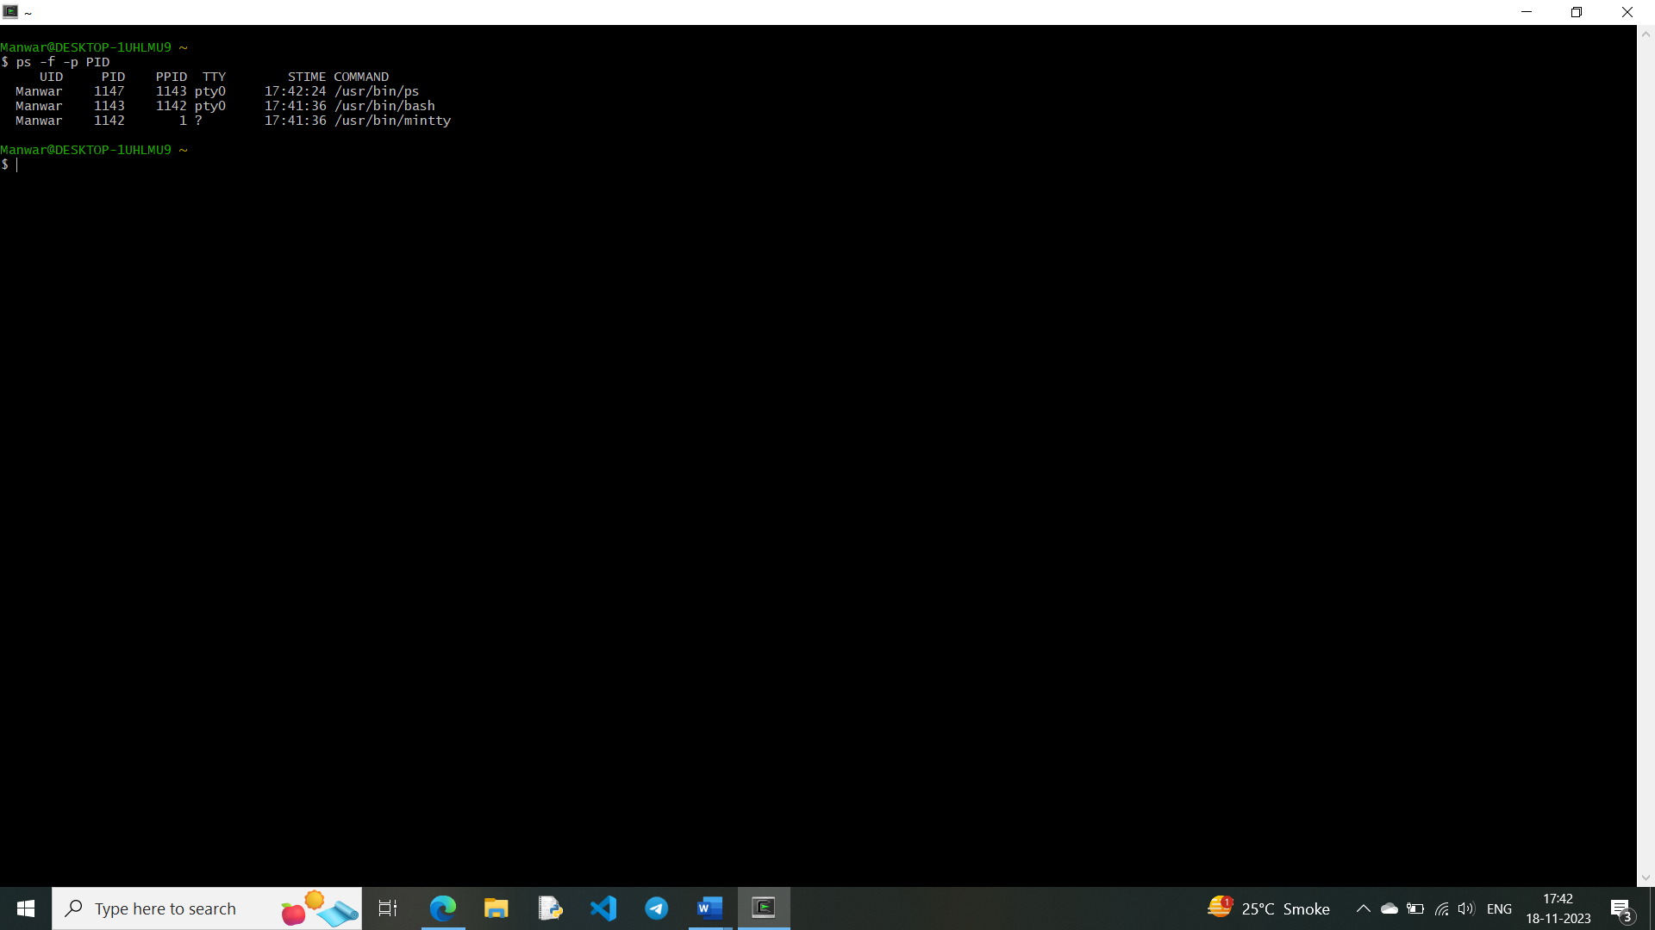

ii. Communication: Input-output redirection, Pipe

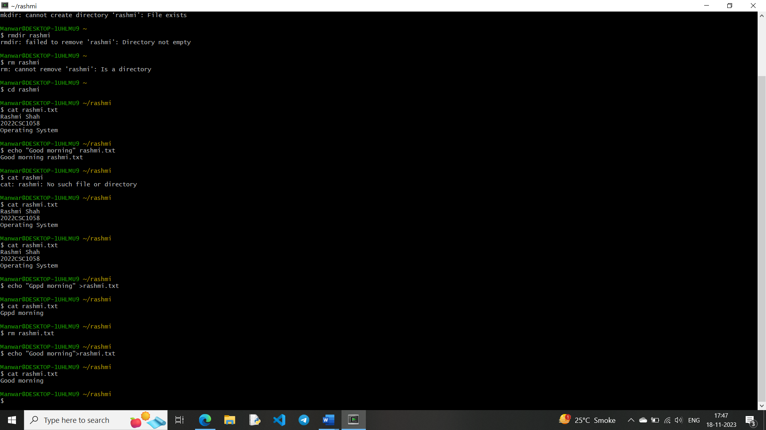

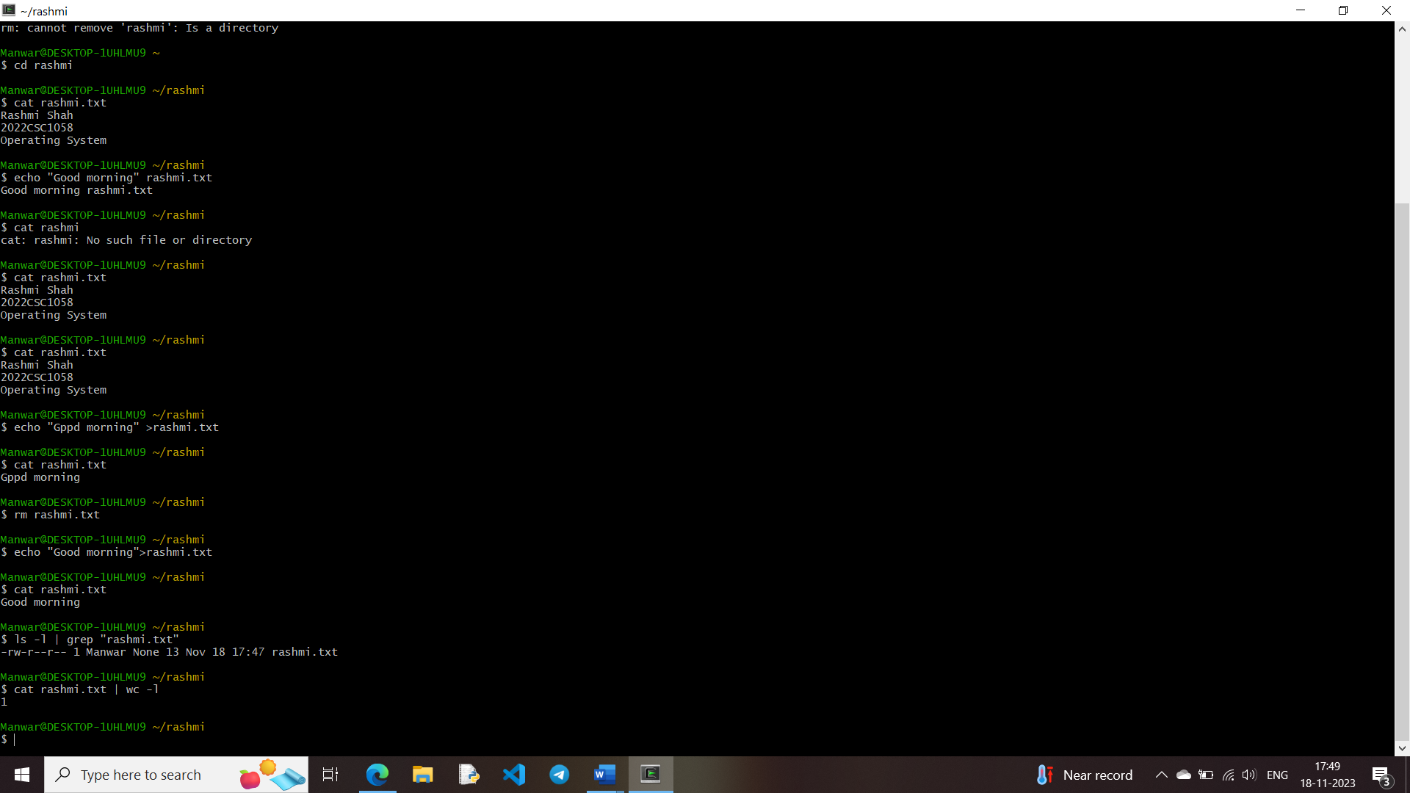

iii. Protection Management: chmod, chown, chgrp

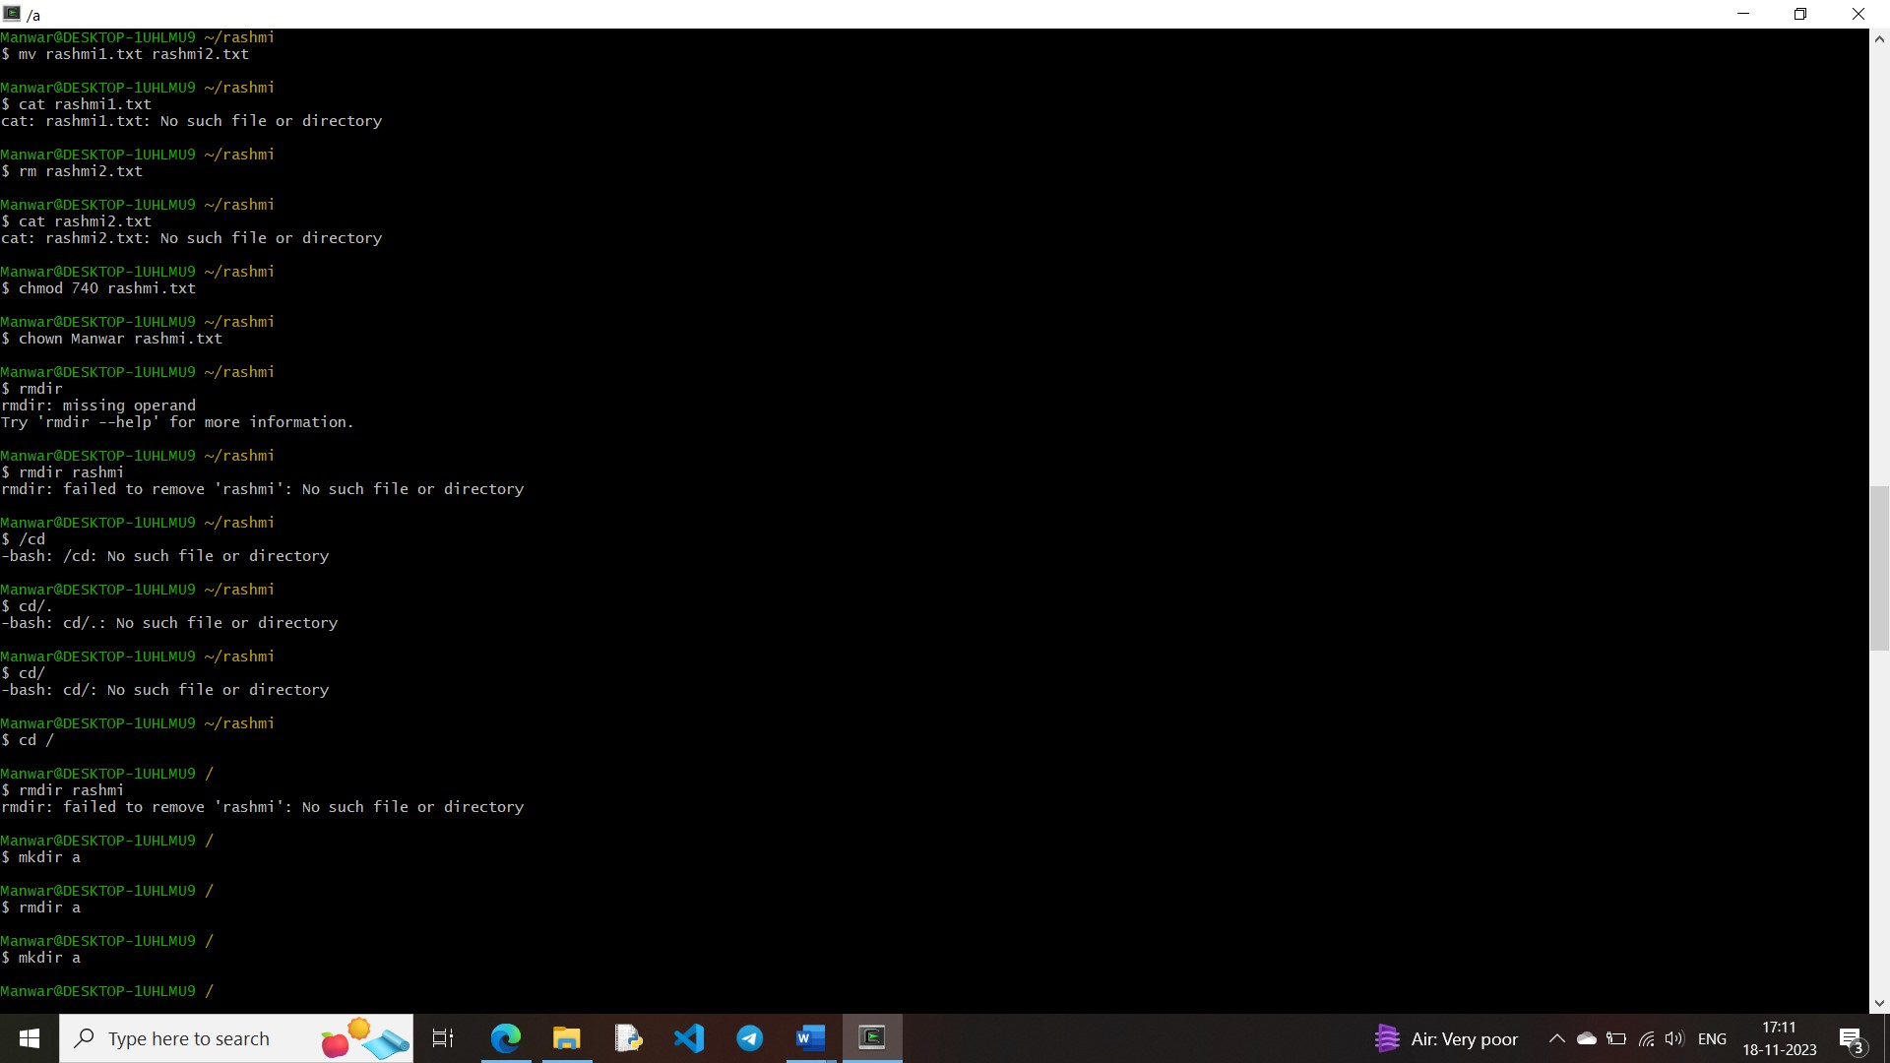



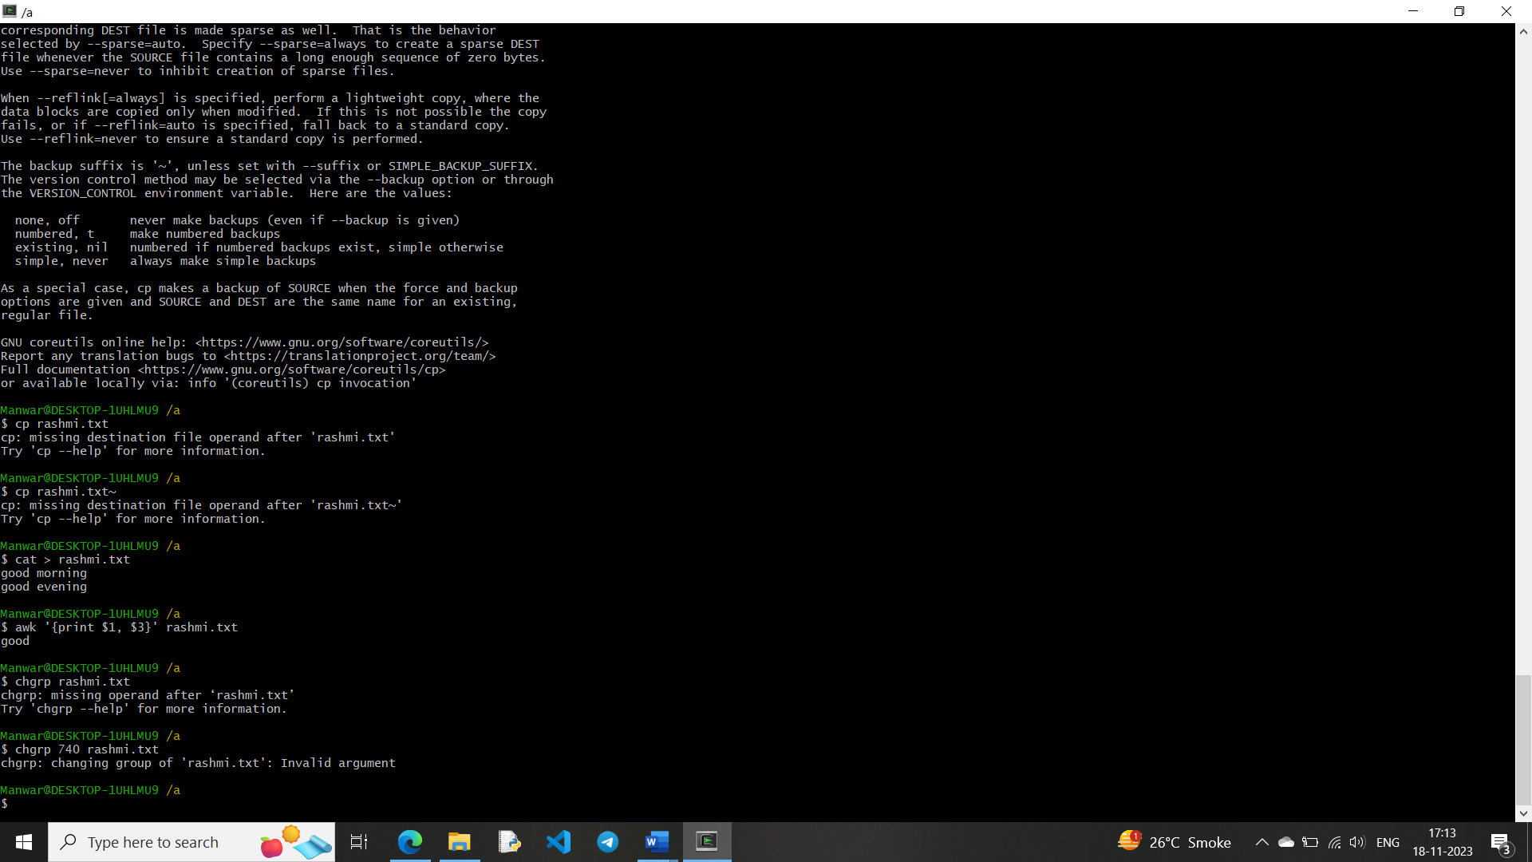

4. Write a programme (using fork() and/or exec() commands) where parent and child execute:

i. same program, same code.

#include <iostream>

#include <unistd.h>

#include <sys/wait.h>

using namespace std;

int main() {

pid_t pid;

pid = fork();

if (pid == -1 ) {

cout << "Error" << endl;

return 1;

} else if (pid == 0) {

cout << "Child process (PID=" << getpid() << ") executing the same program" << endl;

} else {

cout << "Parent process (PID=" << getpid() << ") executing the same program" << endl;

wait(nullptr);

cout << "Parent process (PID=" << getpid() << ") completed" << endl;

}

return 0;

}

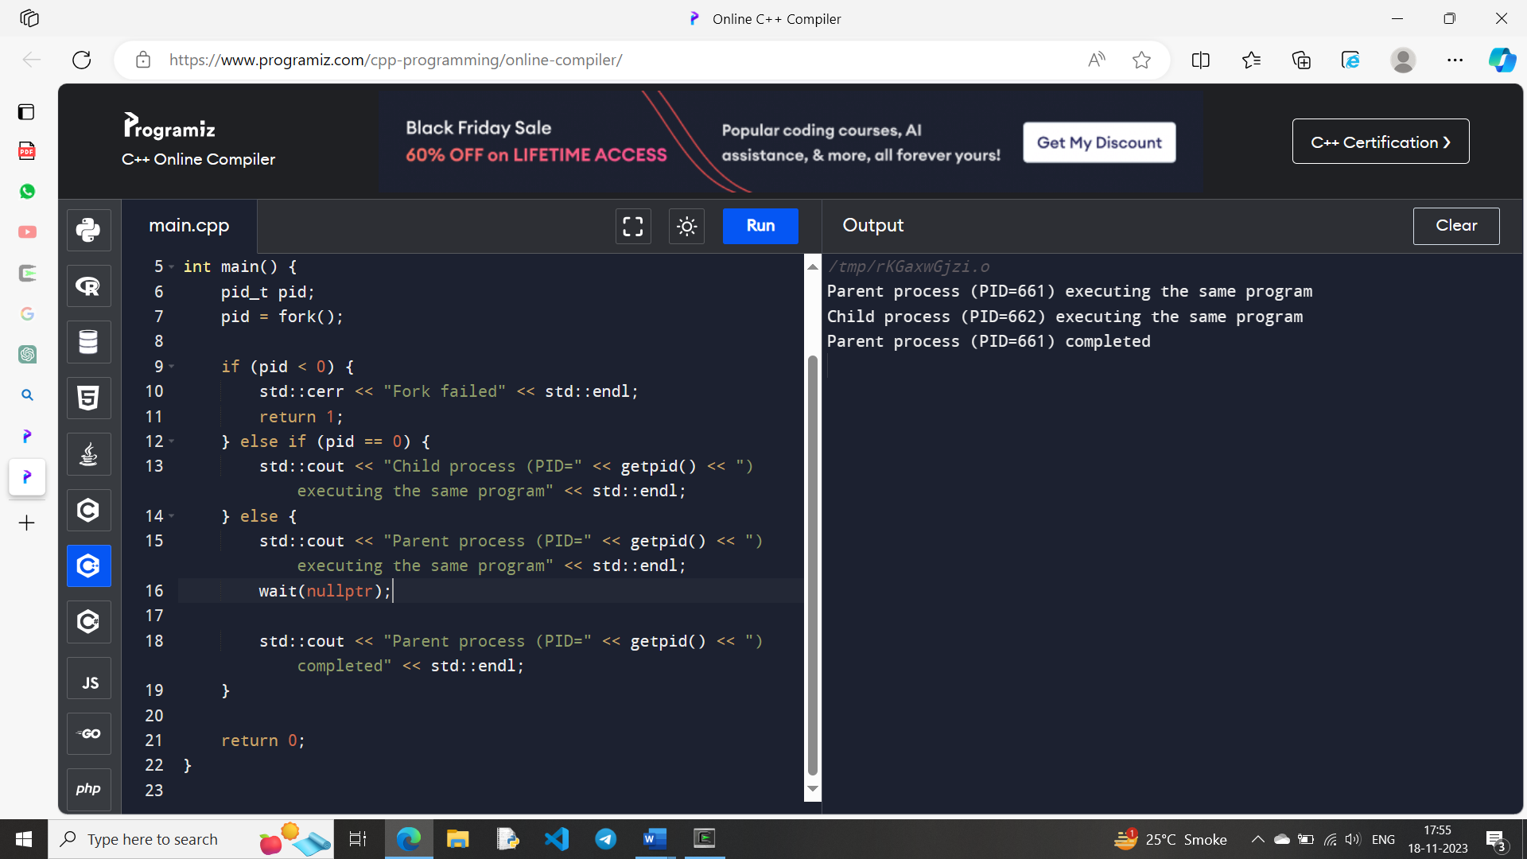

ii. same program, different code.

#include <iostream>

#include <unistd.h>

#include <sys/wait.h>

using namespace std;

int main() {

pid_t pid;

pid = fork();

if (pid == -1) {

cout << "Error" << endl;

return 1;

}

else if (pid == 0) {

cout << "Child process (PID=" << getpid() << ") executing different code" << endl;

for (int i = 0; i < 5; ++i) {

cout << "Child process: " << i << endl;

}

} else {

cout << "Parent process (PID=" << getpid() << ") executing different code" << endl;

wait(nullptr);

cout << "Parent process (PID=" << getpid() << ") completed" << endl;

}

return 0;

}

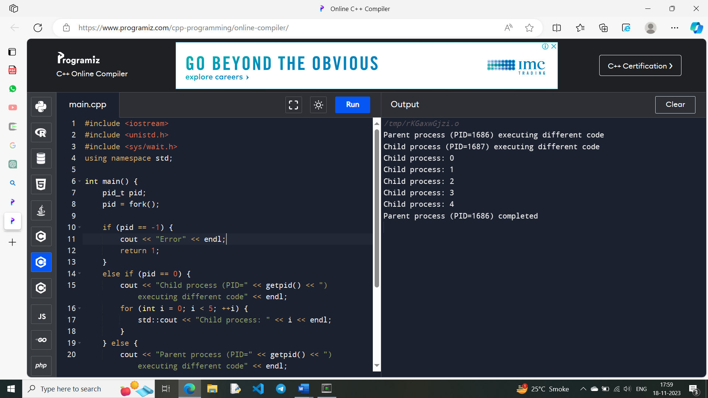

iii. Before terminating, the parent waits for the child to finish its task.

#include <iostream>

#include <unistd.h>

#include <sys/wait.h>

using namespace std;

int main() {

pid_t pid;

pid = fork();

if (pid == -1) {

cout << "Error" << endl;

return 1;

}

else if (pid == 0) {

cout << "Child process (PID=" << getpid() << ") performing its task" << endl;

for (int i = 0; i < 5; ++i) {

cout << "Child process: " << i << endl;

}

cout << "Child process (PID=" << getpid() << ") completed its task" << endl;

}

else {

cout << "Parent process (PID=" << getpid() << ") waiting for the child to finish" << endl;

wait(nullptr);

cout << "Parent process (PID=" << getpid() << ") completed" << endl;

}

return 0;

}

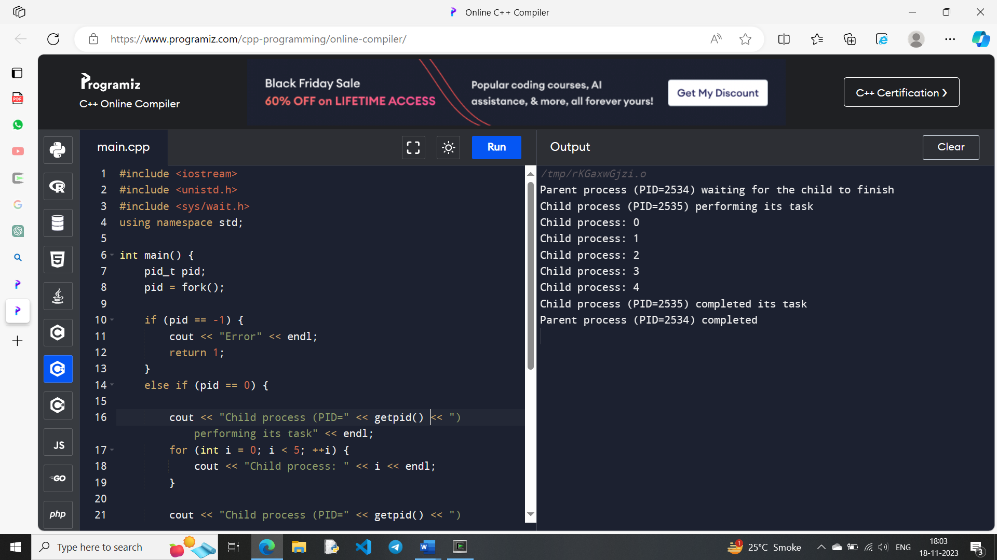

5. Write a program to report behaviour of Linux kernel including kernel version, CPU type and CPU information.

and

6. Write a program to report behaviour of Linux kernel including information on 19 configured memory, amount of free and used memory. (memory information).

#include<iostream>

using namespace std;

int main()

{

int ch;

cout<<"enter your choice :\n";

cout<<"1 for kernel version \n 2 for cpu type and model..\n 3for

information of memory configured,amount of free and used

memory...\n";

cin>>ch;

switch(ch){

case 1: cout<<"\n Kernel version is ....\n";

system("cat /proc/sys/kernel/osrelease");

break;

case 2: cout<<"\n cpu type & model is: \n";

system("awk 'NR==5{print $5}' /proc/cpuinfo");

break;

case 3: cout<<"\n amount of memory configured in system \n";

system("awk 'NR==4{print $0}' /proc/meminfo");

cout<<"\nmemory currently free in system \n";

system("awk 'NR==5{print $0}' /proc/meminfo");

cout<<"\n memory currently used in system \n";

system("awk 'NR==6{print $0}' /proc/meminfo");

 break;

 }

}

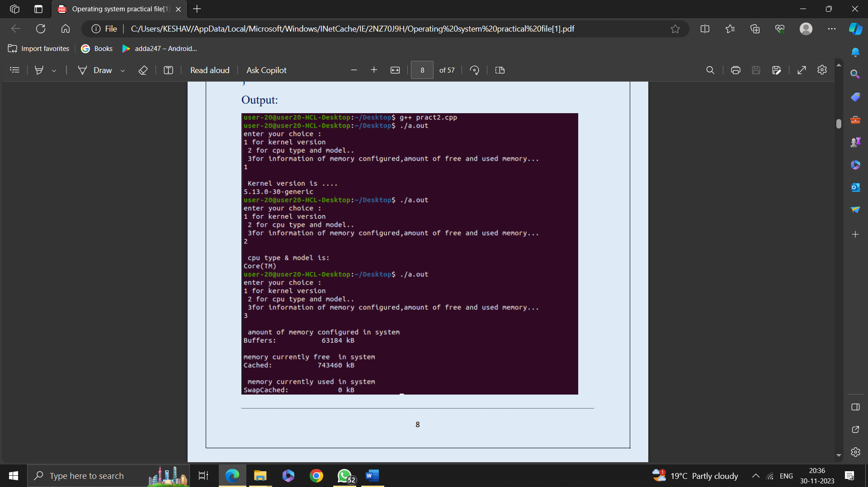

7. Write a program to copy files using system calls.

#include<iostream>

#include<fcntl.h>

#include<unistd.h>

#include<stdio.h>

using namespace std;

int main()

{

char b;

int fd_one,fd_two;

fd_one=open("COPY.TXT",O_RDONLY);

if(fd_one==-1)

{

cout<<"error opening first _filr\n ";

close(fd_one);

return 0;

}

fd_two=open("COPIED_FILE.TXT",O_WRONLY|O_CREAT,S_IRGR

P|S_IROTH);

while(read(fd_one,&b,1)){

write(fd_two,&b,1);

}

cout<<"successfully copied"<<endl;

close(fd_one);

close(fd_two);

}

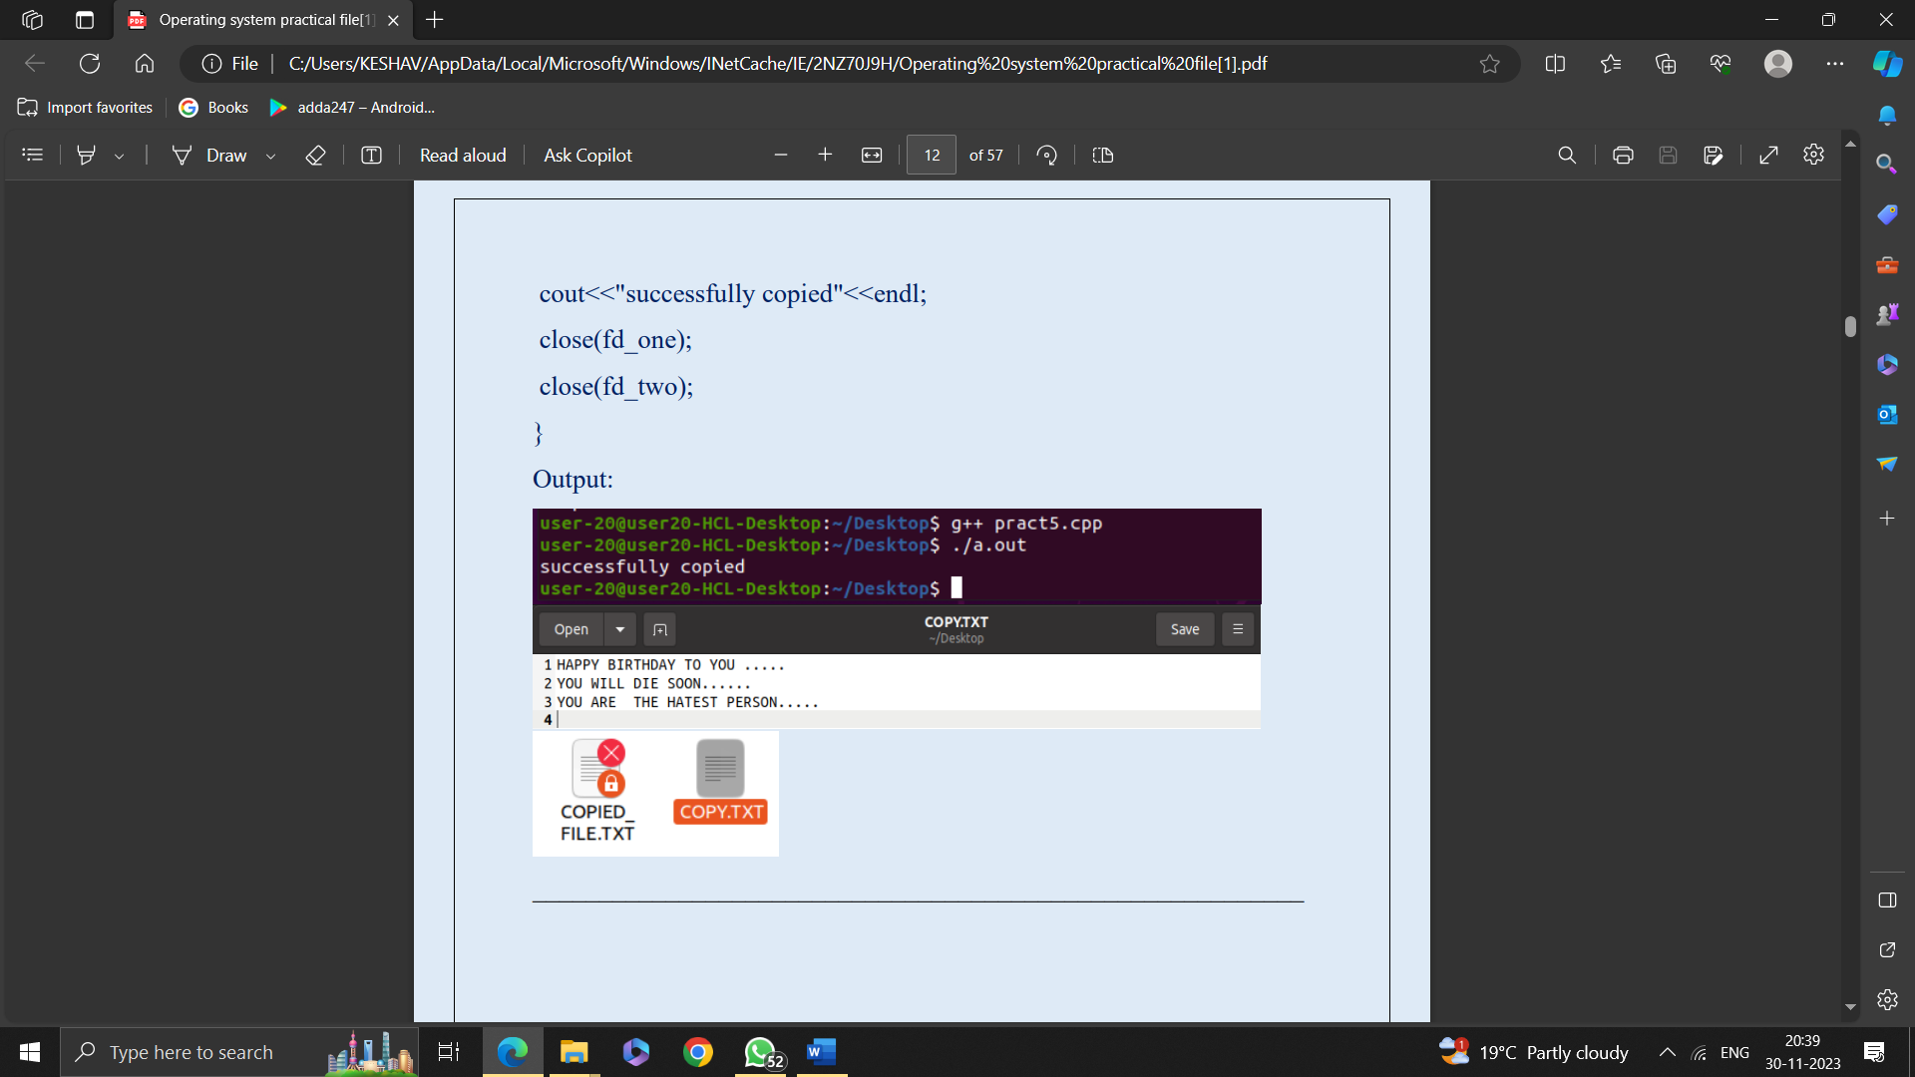

8. WAP to implement First come first serve (FCFS) scheduling algorithm.

#include <iostream>

using namespace std;

struct Process {

int processID;

int arrivalTime;

int burstTime;

int completionTime;

int turnaroundTime;

int waitingTime;

};

void calculateCompletionTime(Process* processes, int numProcesses) {

int currentTime = 0;

for (int i = 0; i < numProcesses; ++i) {

if (processes[i].arrivalTime > currentTime) {

currentTime = processes[i].arrivalTime;

}

processes[i].completionTime = currentTime + processes[i].burstTime;

currentTime = processes[i].completionTime;

}

}

void calculateTurnaroundTime(Process* processes, int numProcesses) {

for (int i = 0; i < numProcesses; ++i) {

processes[i].turnaroundTime = processes[i].completionTime - processes[i].arrivalTime;

}

}

void calculateWaitingTime(Process* processes, int numProcesses) {

for (int i = 0; i < numProcesses; ++i) {

processes[i].waitingTime = processes[i].turnaroundTime - processes[i].burstTime;

}

}

void printProcesses(Process* processes, int numProcesses) {

float avg_TAT = 0;

float avg_WT = 0;

cout << "ProcessID\tArrival Time\tBurst Time\tCompletion Time\tTurnaround Time\tWaiting Time\n";

for (int i = 0; i < numProcesses; ++i) {

avg_TAT += processes[i].turnaroundTime;

avg_WT += processes[i].waitingTime;

cout << processes[i].processID << "\t\t" << processes[i].arrivalTime << "\t\t" << processes[i].burstTime << "\t\t"

<< processes[i].completionTime << "\t\t" << processes[i].turnaroundTime << "\t\t" << processes[i].waitingTime << "\n";

}

cout << "Average turn around time = " << avg_TAT/numProcesses << endl;

cout << "Average Waiting time = " << avg_WT/numProcesses << endl;

}

int main() {

int numProcesses;

cout << "Enter the number of processes: ";

cin >> numProcesses;

Process* processes = new Process[numProcesses];

for (int i = 0; i < numProcesses; ++i) {

cout << "Enter Brust time and Arrival time for Process"<<i+1<<": ";

processes[i].processID = i + 1;

cin>>processes[i].burstTime>>processes[i].arrivalTime;

}

calculateCompletionTime(processes, numProcesses);

calculateTurnaroundTime(processes, numProcesses);

calculateWaitingTime(processes, numProcesses);

printProcesses(processes, numProcesses);

delete[] processes;

return 0;

}

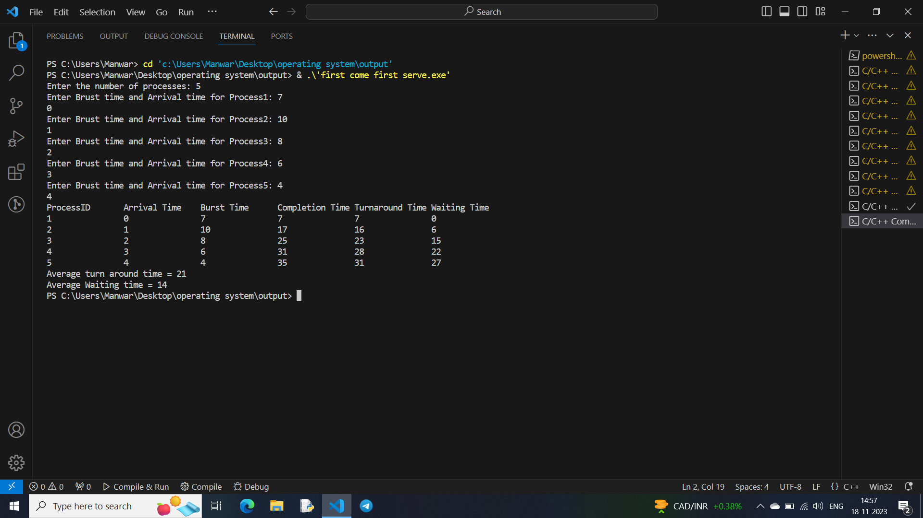

9. WAP to implement Shortest job first (SJF) scheduling algorithm.

#include <iostream>

#include <climits>

using namespace std;

class Process {

public:

int pid;

int brust_time,arrival_time,Waiting_timeP,TAT;

void Enter_Data(int Brust_time,int Arrival_Time=0,int PID=0){

TAT=Brust_time;

brust_time=Brust_time;

arrival_time=Arrival_Time;

pid=PID;

}

};

void SRTF(Process* List,int Size){

int Complete=0;

float Waiting_Time=0,TurnAround_Time=0;

int Time=0,SJI;

bool ProcessGot=false;

while(Complete!=Size){

int min=INT_MAX;

for(int i=0;i<Size;i++){

if((List[i].arrival_time<=Time)&&(List[i].brust_time<=min)&&(List[i].brust_time>0)){

min=List[i].brust_time;

SJI=i; //SHORTEST JOB INDEX

ProcessGot=1;

}

}

if(ProcessGot==0){

Time++;

continue;

}

if(List[SJI].arrival_time>Time){

Time=List[SJI].arrival_time;

}

Time+=List[SJI].TAT;

List[SJI].brust_time=0;

List[SJI].Waiting_timeP=Time-List[SJI].arrival_time-List[SJI].TAT;

List[SJI].TAT+=List[SJI].Waiting_timeP;

Complete++;

ProcessGot=0;

}

cout<<"\nPID\t\tTurn Around Time\t\tWaiting Time"<<endl;

for(int i =0;i<Size;i++){

Waiting_Time+=List[i].Waiting_timeP;

TurnAround_Time+=List[i].TAT;

cout<<List[i].pid<<"\t\t\t"<<List[i].TAT<<"\t\t\t"<<List[i].Waiting_timeP<<endl;

}

cout<<"\n\n";

cout<<"Total Turn Around Time is "<<TurnAround_Time/Size<<"ns"<<endl;

cout<<"Total Waiting Time is "<<Waiting_Time/Size<<"ns"<<endl;

}

int main(){

int size;

cout<<"Enter Number Of Process You Want To Enter: ";

cin>>size;

Process Array[size];

int BTime,ATime;

for(int i=0;i<size;i++){

cout<<"Enter Brust Time and Arrival Time Of Process "<<i+1<<": ";

cin>>BTime>>ATime;

Array[i].Enter_Data(BTime,ATime,i+1);

}

cout<<"\nPID\t\tBrust Time \t\tArrival Time\n";

for(int i=0;i<size;i++){

cout<<i+1<<"\t\t\t"<<Array[i].brust_time<<"\t\t\t"<<Array[i].arrival_time<<endl;

}

cout<<endl<<"....................DISPLAYING RESULT.........................."<<endl;

SRTF(Array,size);

}

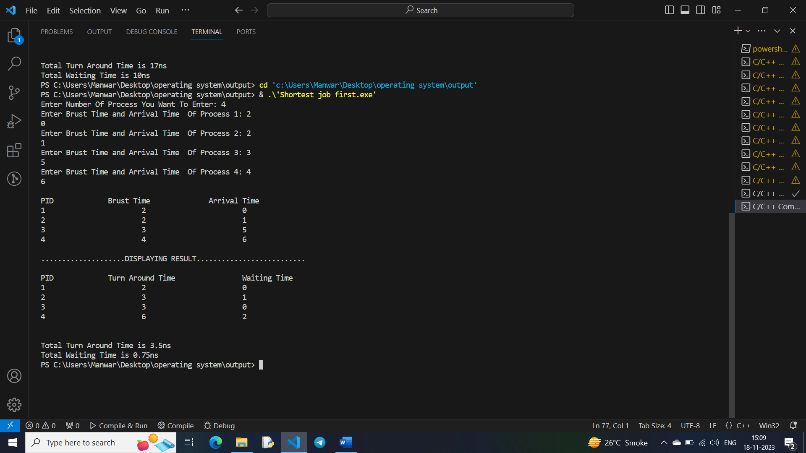

10 .Write a program to implement non-preemptive priority based scheduling algorithm.

#include<iostream>

using namespace std;

int n;

struct process{

int arrival_time;

int burst_time;

int turnaround_time;

int waiting_time;

int start_time;

int completion_time;

int priority;

int pid;

};

int main(){

process p[10];

cout<<"<---NON-PREEMPTIVE PRIORITY SCHEDULING

ALGORITHM(Lower The Number Higher The Priority)--->\n";

cout<<"Enter The Number Of Processes : ";

cin>>n;

for(int i=1 ; i<=n ; i++){

cout<<"\nFOR PROCESS ["<<i<<"]"<<endl;

cout<<"Enter Arrival Time For Process "<<i<<" : ";

cin>>p[i].arrival_time;

cout<<"Enter Burst time for process "<<i <<" : ";

cin>>p[i].burst_time;

cout<<"Enter priority for process "<<i <<" : ";

cin>>p[i].priority;

p[i].pid=i;

}

int temp,temp1,temp3,m=0;

for(int i=1;i<=n;i++){

for(int j=1;j<n;j++){

if(p[j].priority>p[j+1].priority){

temp3=p[j].priority;

p[j].priority=p[j+1].priority;

p[j+1].priority=temp3;

temp=p[j].burst_time;

p[j].burst_time=p[j+1].burst_time;

p[j+1].burst_time=temp;

temp1=p[j].arrival_time;

p[j].arrival_time=p[j+1].arrival_time;

p[j+1].arrival_time=temp1;

m=p[j].pid;

p[j].pid=p[j+1].pid;

p[j+1].pid=m;

}

}

}

int current_time=0;

for(int i=1;i<=n;i++){

p[i].start_time=current_time;

p[i].completion_time=p[i].start_time+p[i].burst_time;

p[i].turnaround_time=p[i].completion_time-p[i].arrival_time;

p[i].waiting_time=p[i].turnaround_time-p[i].burst_time;

current_time=p[i].completion_time;

}

cout<<"\n Process Arrival Time Burst Time Turn Around Time

Waiting Time Priority \n";

for(int i=1 ; i<=n ; i++){

cout<<" P"<<p[i].pid<<"\t\t"<<p[i].arrival_time<<"\t\t

"<<p[i].burst_time<<"\t\t "<<p[i].turnaround_time<<"\t\t

"<<p[i].waiting_time<<"\t\t"<<p[i].priority<<endl;

}

int totalturnaround_time=0;

int totalwaiting_time=0;

for(int i=1;i<=n;i++){

totalturnaround_time+=p[i].turnaround_time

 }

cout<<"\nAverage Turn Around Time :

"<<(totalturnaround_time/n)<<endl;

for(int i=1;i<=n;i++){

totalwaiting_time+=p[i].waiting_time;

}

cout<<"\nAverage Waiting Time : "<<(totalwaiting_time/n)<<endl;

}

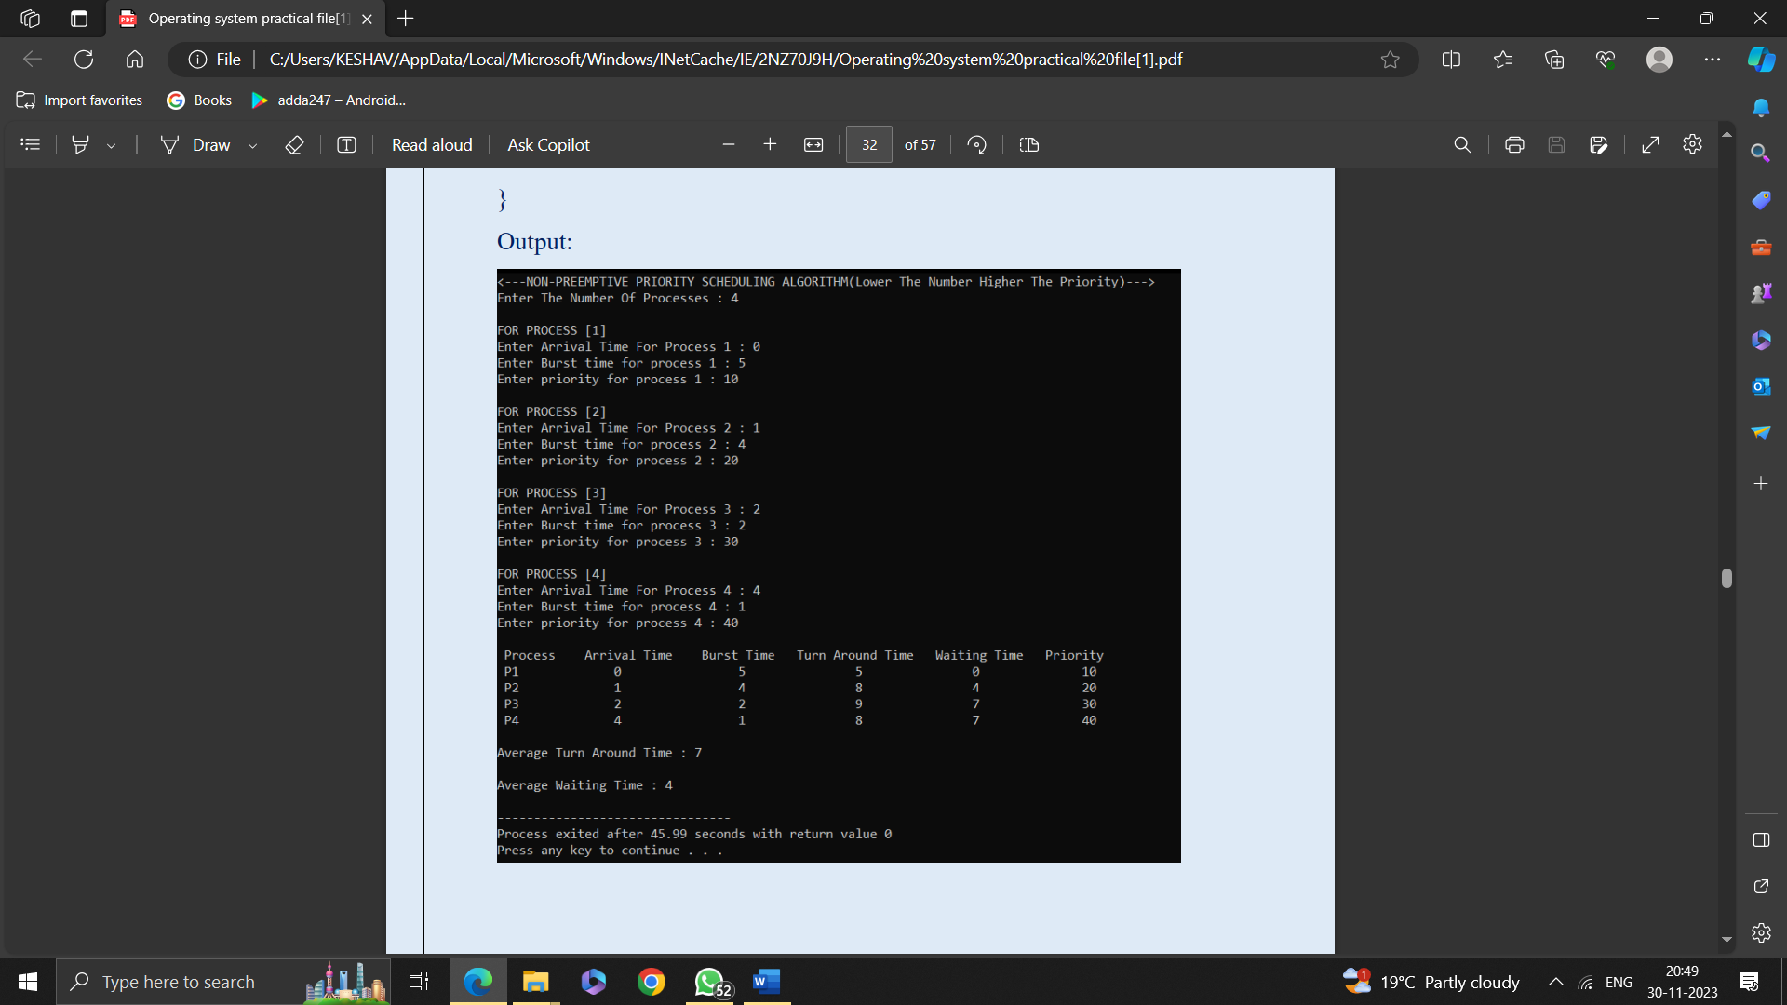

11. Write a program to calculate sum of n numbers using thread library.

#include<iostream>

#include<pthread.h>

using namespace std;

int global[2];

void *sum_thread(void *arg)

{

int *args_array;

args_array=(int*)arg;

int n1,n2,sum;

n1=global[0];

n2=global[1];

sum=n1+n2;

cout<<"\n sum= "<<sum;

return NULL;

}

int main()

{

cout<<"\n First Number: ";

cin>>global[0];

cout<<"\n second Number: ";

 cin>>global[1];

pthread_t tid_sum;

pthread_create(&tid_sum,NULL,sum_thread,(void*)&global);

pthread_join(tid_sum,NULL);

 return 0;

}

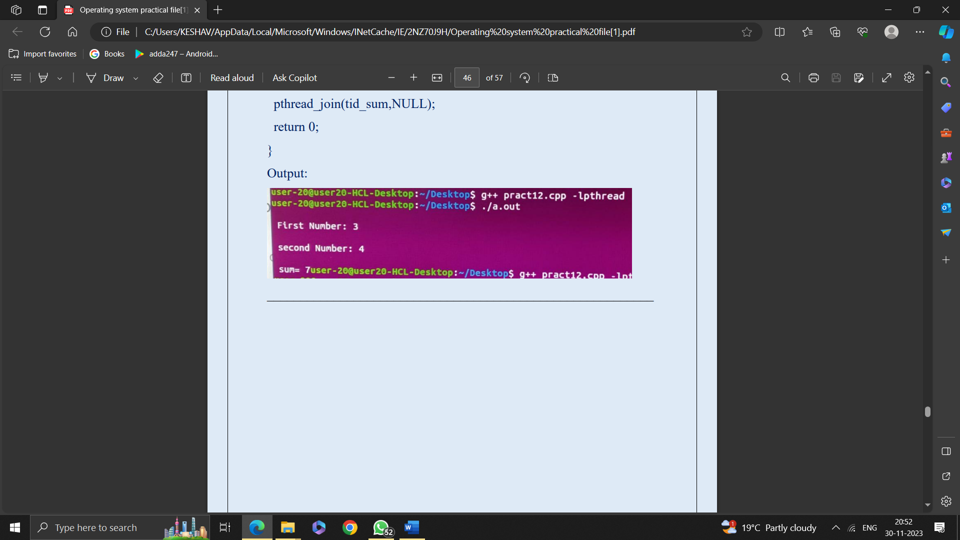

12. Write a program to implement first-fit, best-fit and worst-fit allocation strategies.

#include<iostream>

using namespace std;

void show(int block[],int burst[],int n,int c,int allocation[]){

cout<<"processes No "<<"size "<<"Allocated at "<<"Block size\n";

for(int i=0;i<c;i++){

if(allocation[i]==-1){

cout<<i+1<<"\t"<<burst[i]<<"\t\t"<<"Not Allocated\n";

}

else{

cout<<i+1<<"\t"<<burst[i]<<"\t\t"<<allocation[i]+1<<"\t"<<block[all

ocation[i]]<<"\n";

}

}

}

void first_fit(int block[],int burst[],int n,int c){

int allocation[c];

for(int i=0;i<c;i++)

allocation[i] = -1;

int memoryused[n];

for(int i=0;i<n;i++)

memoryused[i]= 0;

for(int i=0;i<c;i++){//c=No of Processes

for(int j=0;j<n;j++){//j=No of blocks

if((block[j]-memoryused[j])>=burst[i]){

memoryused[j]+=burst[i];

allocation[i]=j;

j=n;

}

}

}

show(block,burst,n,c,allocation);

}

int main(){

cout<<"\n******************************************\n";

cout<<"\n\t\tFIRST FIT \n";

cout<<"\n******************************************\n";

int n,c;

cout<<"\nNo of Memory blocks you want to enter : ";

cin>>n;

int Block[n];

cout<<"\nEnter no of process you want : ";

cin>>c;

int Burst[c];

cout<<"\nEnter Size of memory blocks resp : ";

for(int i=0;i<n;i++)

cin>>Block[i];

cout<<"\nEnter Size of Processess resp : ";

for(int i=0;i<n;i++)

cin>>Burst[i];

first_fit(Block,Burst,n,c);

}

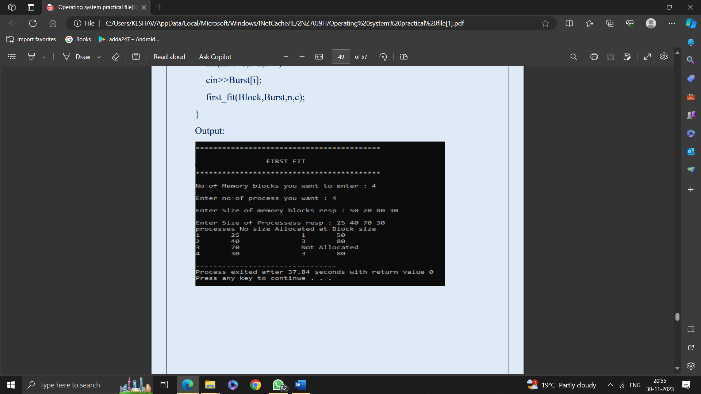

Best Fit

Program:

#include<iostream>

using namespace std;

void show(int block[],int burst[],int n,int c,int allocation[]){

cout<<"processes size "<<"Allocated at "<<"Block size\n";

for(int i=0;i<c;i++){

if(allocation[i]==-1){

cout<<burst[i]<<"\t\t"<<"Not Allocated\n";

}

else{

cout<<burst[i]<<"\t\t"<<allocation[i]+1<<"\t"<<block[allocation[i]]<<"\

n";

}

}

}

void best_fit(int block[],int burst[],int n,int c){

int allocation[c];

for(int i=0;i<c;i++)

allocation[i] = -1;

int memoryused[n];

for(int i=0;i<n;i++)

memoryused[i]= 0;

for(int i=0;i<n-1;i++)

{

for(int j=0;j<n-1;j++)

{

if(block[j]<block[j+1])

{

int t=0;

t=block[j];

block[j]=block[j+1];

block[j+1]=t;

}

}

}

for(int i=0;i<c-1;i++)

{

for(int j=0;j<c-1;j++)

{

if(burst[j]<burst[j+1])

{

int t=0;

t=burst[j];

burst[j]=burst[j+1];

burst[j+1]=t;

}

}

}

for(int i=0;i<c;i++){//c=No of Processes

for(int j=0;j<n;j++){//j=No of blocks

if((block[j]-memoryused[j])>=burst[i]){

memoryused[j]+=burst[i];

allocation[i]=j;

j=n;

}

}

}

show(block,burst,n,c,allocation);

}

int

main(){cout<<"\n******************************************\n

";

cout<<"\n\t\tBEST FIT \n";

cout<<"\n******************************************\n";

int n,c;

cout<<"\nNo of Memory blocks you want to enter : ";

cin>>n;

int Block[n];

cout<<"\nEnter no of process you want : ";

cin>>c;

int Burst[c];

cout<<"\nEnter Size of memory blocks resp : ";

for(int i=0;i<n;i++)

cin>>Block[i];

cout<<"\nEnter Size of Processess resp : ";

for(int i=0;i<n;i++)

cin>>Burst[i];

best_fit(Block,Burst,n,c);

}

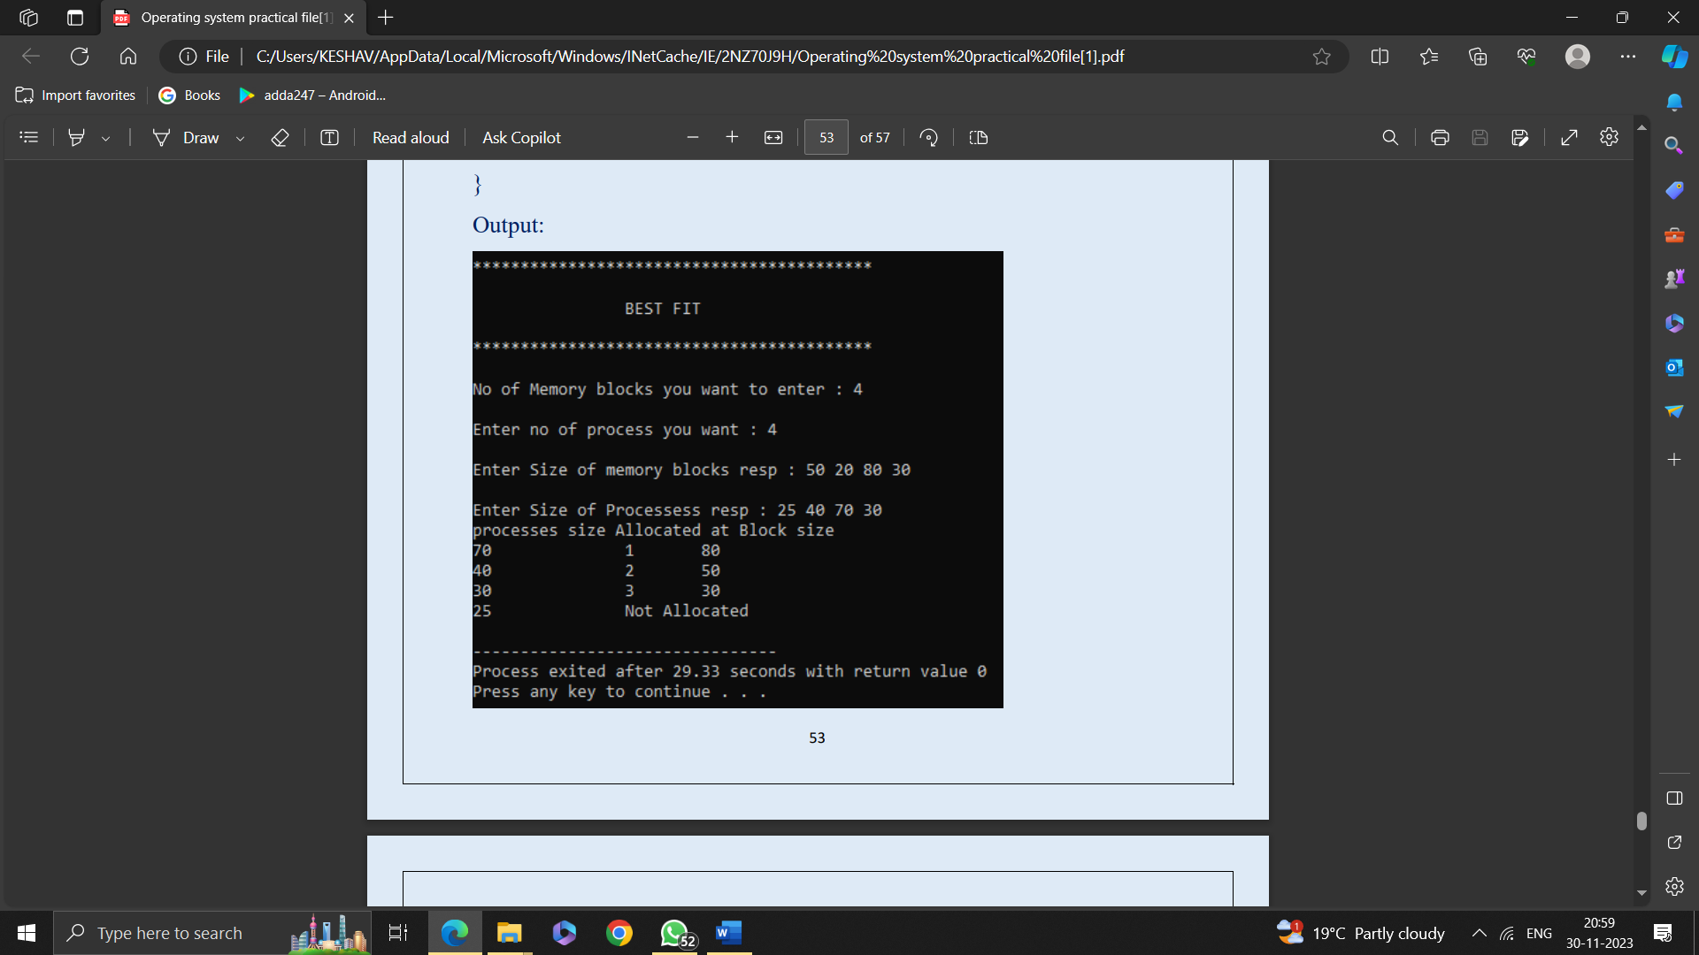

Worst Fit

Program:

#include<iostream>

using namespace std;

void show(int block[],int burst[],int n,int c,int allocation[]){

cout<<"processes size "<<"Allocated at "<<"Block size\n";

for(int i=0;i<c;i++){

if(allocation[i]==-1){

cout<<burst[i]<<"\t\t"<<"Not Allocated\n";

}

else{

cout<<burst[i]<<"\t\t"<<allocation[i]+1<<"\t"<<block[allocation[i]]<<"\

n";

}

}

}

void worst_fit(int block[],int burst[],int n,int c){

int allocation[c];

for(int i=0;i<c;i++)

allocation[i] = -1;

int memoryused[n];

for(int i=0;i<n;i++)

memoryused[i]= 0;

for(int i=0;i<n-1;i++)

{

for(int j=0;j<n-1;j++)

{

if(block[j]<block[j+1])

{

int t=0;

t=block[j];

block[j]=block[j+1];

block[j+1]=t;

}

}

}

for(int i=0;i<c-1;i++)

{

for(int j=0;j<c-1;j++)

{

if(burst[j]>burst[j+1])

{

int t=0;

t=burst[j];

burst[j]=burst[j+1];

burst[j+1]=t;

}

}

}

for(int i=0;i<c;i++){//c=No of Processes

for(int j=0;j<n;j++){//j=No of blocks

if((block[j]-memoryused[j])>=burst[i]){

memoryused[j]+=burst[i];

allocation[i]=j;

j=n;

}

}

}

show(block,burst,n,c,allocation);

}

int main(){

cout<<"\n******************************************\n";

cout<<"\n\t\t WROST FIT \n";

cout<<"\n******************************************\n";

int n,c;

cout<<"\nNo of Memory blocks you want to enter : ";

cin>>n;

int Block[n];

cout<<"\nEnter no of process u want : ";cin>>c;

int Burst[c];

cout<<"\nEnter Size of memory blocks resp : ";

for(int i=0;i<n;i++)

cin>>Block[i];

cout<<"\nEnter Size of Processess resp : ";

for(int i=0;i<n;i++)

cin>>Burst[i];

worst_fit(Block,Burst,n,c);

}

